**VIRTUAL NETBANKING SYSTEM USING ADMINISTRATIVE**

**MODULE**

**A PROJECT REPORT**

***Submitted by***

**JOSEPH WINSTON B [REGISTER NUMBER : 211418104104] VENKATA SAI GUTHALA [REGISTER NUMBER : 211518104073]**

***in partial fulfillment for the award of the degree of***

**BACHELOR OF ENGINEERING**

**IN**

**COMPUTER SCIENCE AND ENGINEERING**

**PANIMALAR ENGINEERING COLLEGE, CHENNAI-600123.**

**(An Autonomous Institution, Affiliated to Anna University, Chennai)**

**MAY 2022**

 

**VIRTUAL NETBANKING SYSTEM USING ADMINISTRATIVE**

**MODULE**

**A PROJECT REPORT**

***Submitted by***

**JOSEPH WINSTON B [REGISTER NUMBER : 211418104104] VENKATA SAI GUTHALA [REGISTER NUMBER : 211518104073]**

***in partial fulfillment for the award of the degree of***

**BACHELOR OF ENGINEERING**

**IN**

**COMPUTER SCIENCE AND ENGINEERING**

**PANIMALAR ENGINEERING COLLEGE, CHENNAI-600123.**

**(An Autonomous Institution, Affiliated to Anna University, Chennai)**

**MAY 2022**

**BONAFIDE CERTIFICATE**

Certified that this project report **“VIRTUAL BANKING SYSTEM WITHADMINISTRATIVE MODULE”** is the bonafide work of “JOSEPH WINSTON B [211418104104], VENKATA SAI GUTHALA [211418104073]**,**

who carried out the project work under supervision.

**SIGNATURE SIGNATURE**

**Dr.S. MURUGAVALLI, M.E., Ph.D., Dr. G. SENTHIL KUMAR, ME., Ph.D.,**

**HEAD OF THE DEPARTMENT SUPERVISOR**

**ASSOCIATE PROFESSOR**

DEPARTMENT OF CSE, DEPARTMENT OF CSE,

PANIMALAR ENGINEERING COLLEGE, PANIMALAR ENGINEERING COLLEGE, NASARATHPETTAI, NASARATHPETTAI,

POONAMALLEE, POONAMALLEE,

CHENNAI-600 123. CHENNAI-600 123.

Certified that the above candidate(s) was/ were examined in the Anna University ProjectViva-Voce Examination held on...........................

**INTERNAL EXAMINER EXTERNAL EXAMINER**

**DECLARATION BY THE STUDENT**

We **JOSEPH WINSTON B [211418104104], VENKATA SAI**

**[211418104073],** hereby declare that this project report titled “VIRTUAL

**NETBANKING SYSTEM WITH ADMINISTRATIVE MODULE”**, under the

guidance of **Dr**. **G. SENTHIL KUMAR,M.E,Ph.D.,** is the original work done by usand we have not plagiarized or submitted to any other degree in any university by us.

**ABSTRACT**

A computer-based Banking system is designed to handle all the primary information required to calculate monthly statements of customer account which include monthly statement of any month. Separate database is maintained to handle all the details required for the correct statement calculation and generation. This project intends to introduce more user friendliness in the various activitiessuch as updating records, maintenance, and searching. The searching of record has been made quite simple as all the details of the customer can be obtained by simply keying in theidentification or account number of that customer. Similarly, record maintenance and updating can also be accomplished by using the accountnumber with all the details being automatically generated. These details are also being promptly automatically updated in the master file thus keeping the record absolutely up-to-date.

|  |  |  |
| --- | --- | --- |
| **FIGNO** | **LIST OF FIGURES**  **FIGURE DESCRIPTION** | **PAGE NO** |
| 4.1 | Data Flow Diagram | 13 |
| 4.1.1 | Admin Panel | 13 |
| 4.1.2 | Transaction | 14 |
| 4.1.3 | Choose Transaction | 14 |
| 4.1.4 | Processing | 14 |
| 4.2 | ER Diagram | 16 |
| 4.3.1 | Use case Diagram | 17 |
| 4.3.2 | Class Diagram | 18 |
| 4.3.3 | Activity Diagram | 19 |
| 4.3.4 | Sequence Diagram | 20 |
| A.9.1 | Command panel | 78 |
| A.9.2 | Website Running | 78 |
| A.9.3 | connecting website with database | 77 |
| A.9.4 | Home Page | 77 |
| A.9.5 | Register new user | 79 |
| A.9.6 | Error Detection Safety measures | 79 |
| A.9.7 | Deposit page | 80 |
| A.9.8 | Transaction report | 80 |
| A.9.9 | Withdrawal page | 81 |
| A.9.10 | Updated Transaction report | 81 |
| A.9.11 | Admin login | 82 |
| A.9.12 | Home page for Admin | 82 |
| A.9.13 | total list of viewers | 83 |
| A.9.14 | View transaction | 83 |

**LIST OF SYMBOLS**

|  |
| --- |
| *Class Name*  *-attribute* |
| *-attribute* |
| *+operation*  *+operation*  *+operation* |

|  |  |  |
| --- | --- | --- |
| Class A | NAM | EClass B |
|  |

|  |  |  |
| --- | --- | --- |
| Class A |  | Class B |
|  |

|  |  |  |  |  |  |  |  |
| --- | --- | --- | --- | --- | --- | --- | --- |
| **S.NO** | **NOTATION**  **NAME** | **NOTATION** | | | | | **DESCRIPTION** |
| 1. | Class | *+ public*  *-private*  *# protected* | | | | | Represents a collection of similar entities grouped together. |
| 2. | Association |  | | | | | Associations represents static relationships between classes. Roles representsthe way the two classes see each other. |
| 3. | Actor |  | | | | | It aggregates several classes into a single classes. |
| 4. | Aggregation |  | Class A |  | Class A |  | Interaction between  the system and external environment |
| Class B Class B | | | | |

**uses**



State of the processs.

State

Communication between various use cases.

Communication

7.

Extends relationship is used when one use case is similar to another use case but does a bit more.

extends

Relation (extends)

6.

Used for additional process communication.

**Relation**

(uses)

5.



Final state of the object

Final state

10.

Initial state of the object

Initial State

State

9.

8.

|  |  |  |  |
| --- | --- | --- | --- |
| 11. | Control flow |  | Represents various control flow between the states. |
| 12. | Decision box |  | Represents decision making process from a constraint |
| 13. | Use case | Uses case | Interact ion between the system and external environment. |
| 14. | Component |  | Represents physical modules which is a collection of components. |
| 15. | Node |  | Represents physical modules which are a collection of  components. |
| 16. | Data Process/State |  | A circle in DFD represents a state or process which has  been triggered due to some event or action. |

|  |  |  |  |
| --- | --- | --- | --- |
| 17. | External entity |  | Represents external entities such as keyboard,sensors,etc. |
| 18. | Transition |  | Represents communication that occurs between processes. |
| 19. | Object Lifeline |  | Represents the vertical dimensions that the object communications. |
| 20. | Message | Message | Represents the message exchanged. |

|  |  |  |
| --- | --- | --- |
|  | **TABLE OF CONTENTS** |  |
| **CHAPTER** | **TITLE** | **PAGE NUMBER** |
|  | **ABSTRACT** | iii |
|  | **LIST OF FIGURES** | iv |
|  | **LIST OF ABBREVATIONS** | v |
| 1 | **INTRODUCTION** | 1 |
|  | 1.1 Introduction | 2 |
| 2 | **LITERATURE REVIEW** | 3 |
|  | 2.1 Literature review | 4 |
| 3 | **SYSTEM ANALYSIS** | 8 |
|  | 3.1 Existing System | 9 |
|  | 3.2 Proposed System | 9 |
|  | 3.3 Feasibility analysis | 10 |
|  | 3.4 Software Requirements | 10 |
|  | 3.5 Hardware Requirements | 11 |
| 4 | **SYSTEM DESIGN** | 12 |
|  | 4.1 Data Flow Diagram | 13 |
|  | 4.2 ER Diagram | 15 |
|  | 4.3 UML Diagrams | 17 |
| 5 | **SYSTEM DESCRIPTION** | 21 |
| 6 | **SOURCE CODE** | 36 |
| 7 | **SYSTEM TESTING** | 69 |
| 8 | **CONCLUSION** | 74 |
|  | 8.1 Future Enhancements | 74 |
| 10 | **APPENDICES** | 76 |
| 11 | **REFERENCES** | 84 |

# CHAPTER 1 INTRODUCTION

## INTRODUCTION

The main purpose that banks have been serving since their inception is keeping our moneysafe for us. While keeping our money safe, they also let us earn a certain amount of interest on the money deposited with them. Traditional banks have been doing this, and internet banks continue the same function. The only difference is in the way the transactions are made.

They all know about internet banking and most of us use it quite often as well, but few of us actually understand about the history of internet banking and how it all came out. Knowing the history ofinternet banking can be incredibly useful, especially since it will allow us to have more respect for the little things that we take for granted.

Internet banking has been around for quite a few years now, but has really only become prominent over the past year or so in particular. Internet banking offers an array of different advantages to the user, including account balances and history including year-to-date information, the ability to transfer money from one account to another and to payees for bill payments, check history, reorders, and stop payments, check credit card balances and statements, complete online loan applications, secure interactive messaging with staff, and much more. Internet banking basically allows you to be able to do everything that you can in your regular banking institution, only with the benefit that you can do it all right from the convenience of your own home. Not only is this great because you can be comfortable and have peace of mind knowing that you can keep track yourself of all your banking issues, but as well it allows for more ease because you never have to worry about rushing out and making it to the bank.

# CHAPTER 2 LITERATURE SURVEY

## Literature Review

The online banking service quality is the attributes of electronic banking that perceived by the customer, service provider, or another party. It is a clear notion that Internet banking and payments are likely to advance more or less in tandem with e-commerce. The Internet revolution is a global phenomenon and going by these growth statistics, India expects a spurt within the web penetration in coming years particularly within electronic commerce. Researches indicate that Internet banking features a significant impact on the business models of banks, securities trading firms, brokerage houses, insurance companies, etc.

Internet banking has also attracted the eye of, regulators and lawmakers within the developing nations since the late 1990s. internet banking could also be a shred of evidence for concern to the bulk of the offline banks who should be ready for unprecedented competition from the non-traditional banking institutions that provide banking and financial services over the Internet.

Although a number of normal banks have started offering their services online, it's onlyan extension of their offline services. Internet banking has now started motivating customers to park their funds with web banks, which features a substantial impact on the deposit base of the B BN B brick-and-mortar banks. Banking has a direct relationship with profit when technology is used in banking. Cetris Paribus, investment in electronic banking increase the margin of profit of banks by reducing costs and increase in noninterest income, which can increase theROA and ROE.

Cost-effectiveness in the delivery of services directly implies comparatively high consumer satisfaction and a consequent change within the revenue model for the banks. Adoption of the web mode of banking would end in increased consumer awareness, attracts the entry of worldwide majors within the market, and would cause the emergence of open standards within the banking system (Treasury Management). The integration of banking services with e-commerce and the emergence of ecash would positively affect the efficiency of many banks.

However, Internet banking could also be a mixed blessing within the sort of increased risk, the extent of confidence reposed by the consumers, and therefore the problem of blending it with the physical system. Internet banking has caused a replacement orientation to risks like settlement risk, international technology transfer risk, crime or fraud risk, regulatory avoidance risk, taxation avoidance risk, and competition risk. Basel II's recommendation on operational risk also supports this hypothesis.

Some Indian banks like HDFC and ICICI have introduced payment gateways running on secure systems having firewalls against hacking. Convenience, safety, and price effectiveness are the jargons within the spectrum of online banking. Researchers on various occasions have raised many issues, which must be addressed in the state of affairs of Internet banking in India. First, the supply of technology and infrastructure to support the new model of banking. Second, the necessity for Internet banking itself – Internet Banking or an efficient system of instantaneous banking or convenient banking.

Third, an adequate mechanism to tackle the safety risk and operational risk aspects. Fourth, a correct legal framework to require care of the rights and obligations of the consumers. While most of thoseissues are somewhat

addressed, a crucial issue still remains - what existing and potential consumers feel about Internet banking and on the idea of this how an appropriate banking model is often developed in the Indian context. There is a requirement to live and analyze the buyer perception towards Internet banking, to seek out what's wrong with traditional banks, and supply a framework for the banks to strategically adopt the webso on maximum value for the consumers.

###### INDIAN BANKING SYSTEM

Banking in India has its origin as early as the Vedic period. it had been believed that transition from money lending to banking must have occurred even before Manu, the good Hindu Jurist, who has devoted a neighborhood of his work to deposit advance and laid down rules concerning rates of interest. During the times of Malay Archipelago Company, it had been turning over the agency houses to hold on to the business.

“The General Bank of India” was the primary to hitch sector within the year 1786. The indigenous Bankers played a very important role in lending money financing foreign trade and commerce at the time of the Mogul period. The others that followed were the Bank of Hindustan and thus the Bengal bank.

The bank of Hindustan is reported to possess continued till 1906 while the opposite two failed within the meantime. In the first half of the 19th century the East India Company established three banks: 1) Bank of Bengal (1809). 2). Bank of Bombay (1840). 3) Bank of Madras (1843) These three banks also are referred to as Presidency Banks were independent units and functioned well. These three banks were affiliatedin 1920 and on 27th January 1921 Imperial Bank of India was established, which started as private shareholders banks, mostly European shareholders, with the passing of

sometime Imperial bank was appropriated by the newly constituted depository

financial organization of India act in 1955.

Allahabad Bank was established in 1865 and exclusively first time established by Indians, Punjab commercial bank Ltd. was found out in 1894 with headquarters at Lahore. Between 1906 and 1913, the Bank of India, financial institution of India, Bank of Baroda, Canara Bank, Indian Bank, and Bank of Mysore were found out.

# CHAPTER 3 SYSTEM ANALYSIS

### SYSTEM ANALYSIS

System analysis is a logical process; the objective of this stage is not actually to solve the problem but to determine what must be done to solve the problem. The basic objective of the analysis stage is to develop the logical model of the system using tools such as UML (Unified modeling language).

###### MAIN OBJECTIVE

* To reduce the manual and paper work
* To provide quick access.
* Easy maintenance of records

###### EXISTING SYSTEM

Existing system is the traditional banking, where customers have to go through the long queue, time wasted and still wouldn’t have access to efficient and effective banking system.

###### PROPOSED SYSTEM

Considering the stress and time taken to go to bank and do transaction. The development of a wellstructure and secured online banking system will allow customer to perform objectives like, creatinga banking system that is easily accessible by customers from the comfort of their homes, offices. Reduce the flow of human traffic and long queues at banks; Promote efficient and effectivebanking for the banks by focusing on those services that still require physical presence at the banking hall. Provides intra-bank funds transfer services

to their customers. Keep a detailed log of customer transactions with the bank on his account. Generate the statement of account of a selected period of time for customers. And provide a customer relationship services.

###### FEASIBILITY STUDY

Feasibility is the determination of whether or not a project is worth doing. The processes are followed in making this determination is called a feasibility study. Feasibility study is the test of system proposal according to its workability, Impact on the organization ability to meet user’s needs, and effective use of resources. The result of feasibility study is a formal proposal. Thisis simply a report – a formal document detailing the nature and scope of the proposed solution.The main objective of a feasibility study is to test the technical, social and economic feasibility of developing a computer system. This is done by investigation the existing system in the area under investigation and generating ideas about a new system. On studying the feasibility of the system, three major considerations are dealt with, to find whether the automation of the system is feasible.

### Software Requirements

###### Application Requirements

* + - Microsoft Windows 2000
    - PHP (Apache Tomcat 5.5)

###### Database Server

* + - My SQL 5.0.

###### Client and Browser

* + - Microsoft Internet Explorer (6+).
    - Mozilla Firefox.

### Hardware Requirements

###### Hardware Requirements (Minimum)

* + - Pentium IV 233MHz.
    - 128 MB RAM.
    - 250 MB free hard disk space.

###### Communication Interface

* + Client on Internet will be using HTTP/HTTPS protocol.
  + Client on Intranet will be using TCP/IP protocol.
  + A Web Browser such as IE 6.0 or equivalent.

# CHAPTER 4 SYSTEM DESIGN

### SYSTEM DESIGN

#### Data Flow Diagrams

* + - This Diagram server two purpose.
      * Provides an indication of how date is transformed as it moves through the system.
      * Disputes the functions and sub functions that transforms the dataflow.
    - The Data flow diagram provides additional information that is used during the analysis ofthe information domain, and server as a basis for the modelling of functions.
    - The description of each function presented in the DFD is contained is a processspecifications called as PSPEC

##### Admin Panel:

Admin Login

View customers

**Fig 4.1.1-Admin panel**

##### Transaction:

Transaction

**Fig 4.1.2-Transaction**

Withdraw

Enquiry

Verification

Deposit

##### Choose Transaction

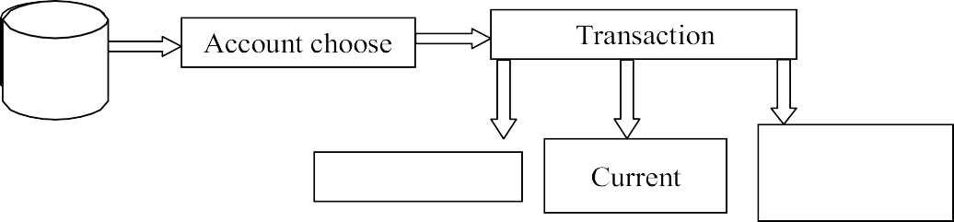

Saving

Fixed deposit

**Fig 4.1.3-Choose Transaction**

##### Processing:

Customer Candidate

Reporting Authority

Database Update

**Fig 4.1.4 -Processing**

* 1. **ER-Diagram**
     + The entity Relationship Diagram (ERD) depicts the relationship between the data objects. The ERD is the notation that is used to conduct the date modelling activity the attributes of each data object noted is the ERD can be described resign a data object description.
       - The set of primary components that are identified by the ER- Diagram are
     + Data object
     + Relationships
     + Attributes
     + Various types of indicators.
       - The primary purpose of the ERD is to represent data objects and their relationships.

##### ER-Diagram

Admin id

Password

Customer id

Password

Manage

s

Address

Phone no

Date of Birth

Age

IS

Funds_transfe

Genera te the account s

Perfor m transa ctions

Generat e trans_li st

Availab le amount

Customer

Displays

Accounts_types

Mini stmts

Balance_enq

Administrator

**Fig4.2-ER Diagram**

## UML DIAGRAMS

##### 4.3.1 USECASE DIAGRAM

The use case diagram is the main building block of [object](http://en.wikipedia.org/wiki/Object_oriented) [oriented](http://en.wikipedia.org/wiki/Object_oriented) modeling. It is used both for general [conceptual modeling](http://en.wikipedia.org/wiki/Conceptual_model) of the systematic of the application, and for detailed modeling translating themodels into [programming code.](http://en.wikipedia.org/wiki/Programming_code)

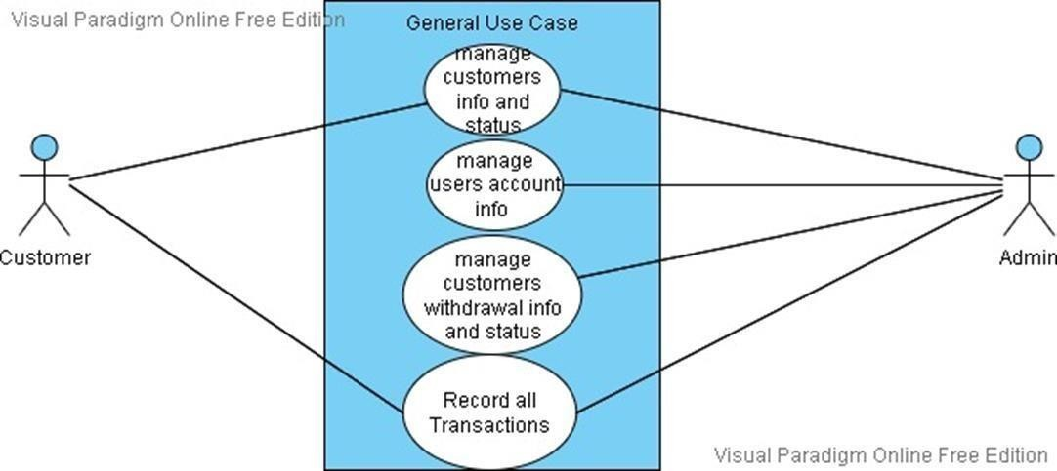

**Fig 4.3.1-Use case diagram**

##### CLASS DIAGRAM:

Class diagram is a type of static structure diagram that describes the structure of a system by showing the system's classes, their attributes, and the relationships between the classes. The classes in a classdiagram represent both the main objects and or interactions in the application and the objects.

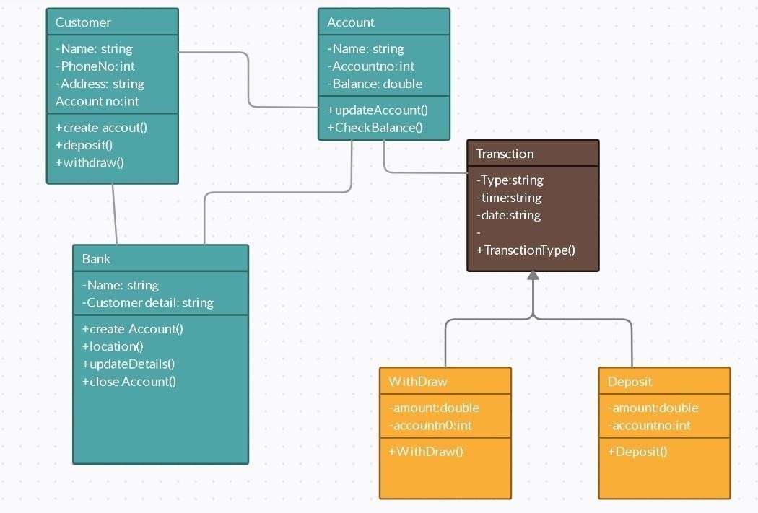

**Fig.4.3.1-Class Diagram**

##### ACTIVITY DIAGRAM

Activity diagram are a loosely defined diagram to show workflows of stepwise activities and actions, with support for choice, iteration and concurrency. UML, activity diagrams can be used to describe the business and operational step- by-step workflows of components in a system. UML activity diagrams could potentially model the internal logic of a complex operation. In many ways UML activity diagrams are the object- oriented equivalent of flow charts and data flow diagrams (DFDs)from structural development.

**START**



Enter userId & Password

Valid user

Funds transfer

Transfer update profile

Mini statements

Your account balance

Transaction amount

Log out

**STOP**

###### Fig.4.3.2-Activity Diagram

* + 1. **SEQUENCE DIAGRAM**

A sequence diagram is the most commonly used interaction diagram. An interaction diagram is used to show the interactive behavior of a system. Since visualizing the interactions in a system can be acumbersome task, we use different types of interaction diagrams to capture various features and aspects of interaction in a system.

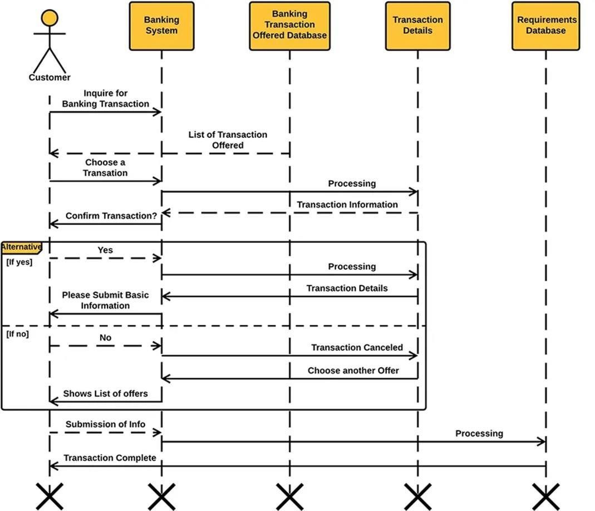

**Fig4.3.3-Sequence Diagram**

# CHAPTER 5 SYSTEM DESCRIPTION

### System Description

#### Users of the system:

In this online internet banking system, the users are

* + - * Administrators
      * Customers

**Administrator**: He is the super user responsible for managing system users, taking system backup, generating reports, maintaining organization details, Starting Sessions and ending Sessions and also manages various requests from different Types of users.

* + - Providing Username, Password and other information required for the users to start an account.
    - **Starting Sessions:** The Administrator creates the system users and will be assigned with the different roles. He is also responsible to start the session when a particular user wants to use the system every time (It is automatically managed setup).
    - **Managing Data Backup:** The Administrator is responsible for managing entire details by taking the backup periodically. He also takes the Backup of the database in order to prevent loss of data on system crashes or in order to prevent malfunctioning. He can take a backup ofentire database or a particular section.
    - **Crash Recovery:** The Administrator manages the crash recovery at the time of system crash or failure occurs.
    - **Ending session:** The administrator is responsible for ending the session when the particular user logged out of the system (It is automatically managed setup).

**Customer (Normal/others):** Ordinary customers have a user name & password with which they can login into their account. They can perform all the transactions such as funds transfer, balance enquiry etc by sitting at their home on internet.

* + - **Login:** User can login to the system by providing appropriate username and passwordprovided by the administrator.
    - **Selecting the Account:** After logging in the user is provided with a screen showingthe details of accounts and he selects one of the accounts in order to perform the transaction.
    - **Balance Enquiry:** He can view the balance left in his account, if once he has enteredinto his account.
    - **Funds Transfer:** Upon the request the user can transfer funds from his account toother accounts.
    - **Mini statements:** He also can take a mini statement print out upon his requirement.

### Database Design

##### CustomerAI

|  |  |  |
| --- | --- | --- |
| **Field Name** | **Data Type** | **SIZE** |
| AccountNo | Varchar | 5  0 |
| A_Sno | Int | 4 |
| UserID | Varchar | 5  0 |
| AccountName | Varchar | 5  0 |
| AccountType | Varchar | 5  0 |
| Balance | Int | - |

**Login Details**

|  |  |  |
| --- | --- | --- |
| **Field Name** | **Data Type** | **SIZE** |
| Sno | Int | 15 |
| UserID | Varchar | 20 |
| Password | Varchar | 20 |

##### Mini_stat

|  |  |  |
| --- | --- | --- |
| **Field Name** | **Data Type** | **SIZE** |
| UserID | Varchar | **50** |
| T_date | Date | - |
| T_Id | Int | 20 |
| T_Accountno | Int | 20 |
| T_Amount | Int | - |

**CustomerPI**

|  |  |  |
| --- | --- | --- |
| **Field Name** | **Data Type** | **SIZE** |
| UserID | Varchar | 50 |
| FirstName | Varchar | 50 |
| LastName | Varchar | 50 |
| FatherName | Varchar | 50 |
| R_Address | Varchar | 500 |
| DOB | Varchar | 50 |
| Age | Int | 2 |
| Landline_No | Varchar | 20 |
| Mobile_Phone | Varchar | 10 |
| Nationality | Varchar | 10 |
| Email | Varchar | 50 |
| Occupation | Varchar | 50 |
| O_Address | Varchar | 50 |
| Office_phone | Varchar | 50 |
| Employer | Varchar | 50 |
| City | Varchar | 50 |
| Pincode | Varchar | 50 |
| State | Varchar | 50 |
| Country | Varchar | 50 |

##### Bankdb (Transaction List)

|  |  |  |
| --- | --- | --- |
| **Field Name** | **Data Type** | **SIZE** |
| T_Id | Int | 30 |
| AccountNo | Varchar | 50 |
| TDate | Varchar | 50 |
| Debit | Int | 20 |
| Credit | Int | 20 |
| Balance | Int | - |
| DepositAcct | Varchar | 50 |
| WithdrawAcct | Varchar | 50 |

###### MODULES

The Online banking Application project will be divided into 4 modules namely:

* + - Login
    - Registration
    - Account Information
    - Transaction

### 5.2.1Description

**Login:** The customer is asked to enter user name & password. When the user enters the details & submits it goes to a validation engine where it checks valid/not. If valid he is shown with list of accounts he has with the bank.

**Authentication** provides a way of identifying a user, typically by having the user enter a valid user name and valid password before access is granted. The process of authentication is based on each user having a unique set

of criteria for gaining access. Server compares a user's authentication credentials with other user credentials stored in a database. If the credentials match, the user is granted access to the account. If the credentials are at variance, authentication failsand account access is denied.

**Authorization:** service manages authentication, authorization, and access control to user accounts, subject to approval from the account holder. several account authorization APIs to accommodate different types of access. After Authentication a user will be verified for performing the various tasks, It access is limited it is known as authorization

**Registration:** Once your registration is complete you will be able to access all of your accounts, with information asked in the prompts during the registration process. We use this information to authenticate you as a user with access to the retail loan or lease account. Details such as name. addphone 20

###### Account Information:

* **Selecting the Account:** After logging in the user is choose the details of accounts and heselects one of the accounts in order to perform the transaction.
* **Balance Enquiry:** The balance details of a particular account to display.

Balance of current account, fixed and saving account

**Transaction:** This module maintains the information related to the funds that have been transferred by the customer from one of his account to another account of his own. This module helps the customer in executing the fund

transfer without the physical visit to the bank’s premises.

* **Mini Statement:** When the user requests for mini statements in the home page, system asks the type of statement needed by the customer. When the customer selects the type ofstatement. The system displays the list of transactions on the screen. If the customer wantsto take print outs, he can take the print outs of the same.
  1. **Tools and Technologies used**

##### PHP

PHP: *Hypertext Preprocessor* (the name being a recursive acronym) is a widely used, general- purpose scripting language that was originally designed for web development to produce dynamic web pages. For this purpose, PHP code is embedded into the HTML source document and interpreted bya web server with a PHP processor module, which generates the web page document. As a general- purpose programming language, PHP code is processed by an interpreter application in command -line mode performing desired operating system operations and producing program output on its standard output channel. It may also function as a graphical application. PHP is available as a processor for most modern web servers and as standalone interpreter on most operating systems and computing platforms.

PHP was originally created by Rasmus Lerdorf in 1995 and has been in continuous development ever since. The main implementation of PHP is now produced by The PHP Group and serves as the de facto standard for PHP as there is no formal specification. PHP is free software released under the PHP License, which is incompatible with the GNU General Public License (GPL) because restrictions exist regarding the use of the term PHP.

* + 1. **Security**

The National Vulnerability Database stores all vulnerabilities found in computer software. The overall proportion of PHP-related vulnerabilities on the database amounted to: 20% in 2004, 28% in 2005, 43% in 2006, 36% in 2007, 35% in 2008, and 30% in 2009. Most of these PHP- related vulnerabilities can be exploited remotely: they allow hackers to steal or destroy data from data

sources linked to the webserver (such as an SQL database), send spam or contribute to DoS attacks using malware, which itself can be installed on the vulnerable servers.

These vulnerabilities are caused mostly by not following best practice programming rules: technical security flaws of the language itself or of its core libraries are not frequent (23 in 2008, about 1% of the total). Recognizing that programmers cannot be trusted, some languages include taint checking to detect automatically the lack of input validation which induces many issues. Such a feature is being developed for PHP, but its inclusion in a release has been rejected several times in the past.

Hosting PHP applications on a server requires a careful and constant attention to deal with these security risks. There are advanced protection patches such as Suhosin and Hardening-Patch, especially designed for web hosting environments.

### Speed optimization

As with any interpreted language, PHP scripts are stored as human- readable source code and are compiled on-the-fly by the PHP engine. In order to speed up execution time and not have to compile the PHP source code every time the webpage is accessed, PHP scripts can also be stored in binary format using PHP compilers such as phc and roadsend.

Code optimizers aim to reduce the runtime of the compiled code by reducing its size and making other changes that can reduce the execution time with the goal of improving performance.The nature of the PHP compiler is such that there are often opportunities for code optimization, and an example of a code optimizer is the eAccelerator PHP extension.

Another approach for reducing overhead for high load PHP servers is using an Opcode cache. Opcode caches work by caching the compiled form of a PHP script (opcodes) in shared memory to avoid the overhead of parsing and compiling the code every time the script runs.

### Resources

PHP includes free and open-source libraries with the core build. PHP is a fundamentally Internet-aware system with modules built in for accessing FTP servers, many database servers, embedded SQL libraries such as embedded PostgreSQL, MySQL and SQLite, LDAP servers, and others. Many functions familiar to C programmers such as those in the stdio family are available in the standard PHP build.

PHP allows developers to write extensions in C to add functionality to the PHP language. These can then be compiled into PHP or loaded dynamically at runtime. Extensions have been written to add support for the Windows API, process management on Unix-like operating systems, multibyte strings (Unicode), cURL, and several popular compression formats. Some more unusual

features include integration with Internet Relay Chat, dynamic generation of images and Adobe Flash content,and even speech synthesis. The PHP Extension Community Library (PECL) project is a repository for extensions to the PHP language.

### My- SQL

MySQL is a relational database management system (RDBMS)

* + - 1. That runs as a server providing multi-user access to a number of databases. MySQL is officially pronounced (My S-Q-L), but often

pronounced (My SeQueL).

* + - 1. The MySQL development project has made its source code available under the terms of the GNU General Public License, as well as under a variety of proprietary agreements. MySQL is owned and sponsored by a single for-profit firm, the Swedish company MySQL AB, now owned by Sun Microsystems, a subsidiary of Oracle Corporation.

Members of the MySQL community have created several forks such asDrizzle and MariaDB. Bothforks were in progress long before the Oracle

##### Uses

Many web applications use MySQL as the database component of a LAMP software stack. Its popularity for use with web applications is closely tied to the popularity of PHP,which is often combined with MySQL

##### Platforms and interfaces

MySQL code uses C and C++. The SQL parser uses yacc and a home-brewed lexer. It is works on many different system platforms, including AIX, BSDi, FreeBSD, HP- UX, i5/OS, Linux, Mac OS X, NetBSD, Novell NetWare, OpenBSD, OpenSolaris, eComStation, OS/2 Warp, QNX, IRIX, Solaris, Symbian, SunOS, SCO OpenServer and Microsoft Windows. All major programming languages with language- specific APIs include Libraries for accessing MySQL databases. In addition, an ODBC interface called MyODBC allows additional programming languages that supportthe ODBC interface to communicate with a MySQL database, such as ASP or ColdFusion. The MySQL server and official

libraries are mostly implemented in ANSI C &ANSI C++.

* + 1. **Database**

A collection of programs that enables you to store, modify, and extract information from a database. Information of the users gets stored in a relational database. The application works wellwith MS- Access as database, it also works well with MySQL, SQL Server 2000 and Oracle.

Data **Manipulation Language (DML)** is used to modify the data present in database:

* SELECT - extracts data from a database table
* UPDATE - updates data in a database table
* DELETE - deletes data from a database table
* INSERT INTO - inserts new data into a database table

The **Data Definition Language (DDL)** is used to define the data:

* CREATE TABLE - creates a new database table
* ALTER TABLE - alters (changes) a database table
* DROP TABLE - deletes a database table
* CREATE INDEX - creates an index (search key)
* DROP INDEX - deletes an index

### Official

The official MySQL Workbench is a free integrated environment developed by MySQL AB, that enables users to graphically administer MySQL databases and visually design database structure. MySQL Workbench replaces the previous package of software, MySQL GUI Tools. Similar to other third-party packages but still considered the authoritative MySQL frontend, MySQL Workbench lets users manage the following:

* + Database design & modeling
  + SQL development — replacing MySQL Query Browser
  + Database administration — replacing MySQL Administrator

In this project, MySQL is used as the backend database. MySQL is an opensource database management system. The features of MySQL are given below

* + - MySQL is a relational database management system. A relational database stores information in different tables, rather than in one giant table. These tables can be referenced to each other,to access and maintain data easily.
    - MySQL is open-source database system. The database software can be used and modify by anyone according to their needs.
    - It is fast, reliable and easy to use. To improve the performance, MySQL is multithreaded database engine. A multithreaded application performs many tasks at the same time as if multiple instances of that application were running simultaneously.

In being multithreaded MySQL has many advantages. A separate thread handles each incoming connection with an extra thread that is always running

to manage the connections. Multiple clients can perform read operations simultaneously, but while writing, only hold up another client that needs access to the data being updated. Even though the threads share the same process space, they execute individually and because of this separation, multiprocessor machines can spread the thread across many CPUs as long as the host operating system supports multiple CPUs. Multithreading is the key feature to support MySQL’s performance design goals. It is the core feature around which MySQL is built.

# CHAPTER 6 SOURCE CODE

## Source code

<?php ob_start ();

define('ROOT_PATH', dirname( FILE ));

if(!is_file(ROOT_PATH . '/lib/confs/Conf.php')) { header('Location: ./install.php'); exit ();

}

session_start(); if(!isset($_SESSION['fnam e'])) {

header("Location:

./login.php");exit();

}

if(isset($_GET['ACT']) &&

$_GET['ACT']=='logout') { session_destroy(); setcookie('Loggedin', '', time()-3600,

'/');header("Location: ./login.php"); exit();

}

define('Admin', 'MOD001');

define('PIM', 'MOD002');

define('MT', 'MOD003');

define('Report', 'MOD004');

define('Leave', 'MOD005'); define('TimeM', 'MOD006');

define('Benefits',

'MOD007');

define('Recruit', 'MOD008');

$arrRights=array('add'=> false , 'edit'=> false , 'delete'=> false, 'view'=> false);

$arrAllRights=array(Admin => $arrRights,

PIM =>

$arrRights, MT =>

$arrRights, Report

=> $arrRights, Leave =>

$arrRights, TimeM

=> $arrRights, Benefits =>

$arrRights,

Recruit => $arrRights);

require_once ROOT_PATH . '/lib/models/maintenance/Rights.php'; require_once ROOT_PATH . '/lib/models/maintenance/UserGroups.php'; require_once ROOT_PATH . '/lib/common/CommonFunctions.php'; require_once ROOT_PATH . '/lib/common/Config.php';

require_once ROOT_PATH . '/lib/common/authorize.php';

$_SESSION['path'] = ROOT_PATH;

?>

<?php

/* Default modules */

if (!isset ($_GET['menu_no_top'])) { if ($_SESSION['isAdmin'] == 'Yes') {

$_GET['menu_no_top'] = "hr";

} else if ($_SESSION['isSupervisor']) {

$_GET['menu_no_top'] = "ess";

} else {

$_GET['menu_no_top'] = "ess";

}

}

/* For checking TimesheetPeriodStartDaySet status :

Begins */if (Config::getTimePeriodSet()) {

$_SESSION['timePeriodSet'] = 'Yes';

} else {

$_SESSION['timePeriodSet'] = 'No';

}

/* For checking TimesheetPeriodStartDaySet status : Ends */

if($_SESSION['isAdmin']=='Yes') {

$rights = new Rights();

// $arrRights=array('add'=> true , 'edit'=> true, 'delete'=> true, 'view'=> true);foreach ($arrAllRights as

$moduleCode=>$currRights) {

$arrAllRights[$moduleCode]=$rights->getRights($_SESSION['userGroup'],

$moduleCode);

}

$ugroup = new UserGroups();

$ugDet = $ugroup ->filterUserGroups($_SESSION['userGroup']);

$arrRights['repDef'] = $ugDet[0][2] == '1' ? true : false;

} else {

/* Assign supervisors edit and view rights to the PIM

* They have PIM rights over their subordinates, but they cannot add/delete
* employees. But they have add/delete rights in the employee details page.

*/

if ($_SESSION['isSupervisor']) {

$arrAllRights[PIM]=array('add'=> false , 'edit'=> true , 'delete'=> false,

'view'=> true);

}

/*

* Assign Manager's access to recruitment module

*/

if ($_SESSION['isManager'] || $_SESSION['isDirector'] || (isset($_SESSION['isAcceptor']) &&

$_SESSION['isAcceptor']) || (isset($_SESSION['isOfferer']) &&

$_SESSION['isOfferer'])){

$arrAllRights[Recruit]=array('add'=> false , 'edit'=> true , 'delete'=> false, 'view'=>

true);

}

}

switch

($_GET['menu_no_to p']) {case "eim":

$arrRights=$arrAllRights[Admi n];break;

case "hr" :

$arrRights=$arrAllRights[PI M];break;

case "mt" :

$arrRights=$arrAllRights[M T];break;

case "rep" :

$arrRights=$arrAllRights[Repo rt];break;

case "leave" :

$arrRights=$arrAllRights[Leav e];break;

case "time" :

$arrRights=$arrAllRights[Time M];break;

case "recruit" :

$arrRights=$arrAllRights[Recru it];break;

}

$_SESSION['localRights']=$arrRights;

$styleSheet = CommonFunctions::getTheme();

$authorizeObj = new authorize($_SESSION['empID'], $_SESSION['isAdmin']);

// Default leave home page

if ($authorizeObj->isAdmin()){

$leaveHomePage = 'lib/controllers/CentralController.php? leavecode=Leave&action=Leave_FetchLeaveAdmin&NewQuery= 1';

} else if ($authorizeObj-

>isSupervisor()) {if ($authorizeObj->isAdmin()){

$leaveHomePage = 'lib/controllers/CentralController.php? leavecode=Leave&action=Leave_HomeSupervisor';

} else {

$leaveHomePage = 'lib/controllers/CentralController.php? leavecode=Leave&action=Leave_FetchLeaveSupervisor';

}

} else if ($authorizeObj->isESS()) {

$leaveHomePage = 'lib/controllers/CentralController.php? leavecode=Leave&action=Leave_Summary&id='.$_SESSION['em pID'];

}

// Time module default pages

if (!$authorizeObj->isAdmin() && $authorizeObj-

>isESS()) {if ($_SESSION['timePeriodSet']

== 'Yes') {

$timeHomePage = 'lib/controllers/CentralController.php? timecode=Time&action=View_Current_Timesheet';

} else {

$timeHomePage = 'lib/controllers/CentralController.php? timecode=Time&action=Work_Week_Edit_View';

}

$timesheetPage = 'javascript: location.href = \'' .

$_SESSION['WPATH'] . '/lib/controllers/CentralController.php? timecode=Time&action=View_Current_Timesheet&clientTimezoneOffset

=\' + escape((newDate()).getTimezoneOffset() * -1);';

} else

{ if ($_SESSION['timePeriodSet'] == 'Yes') {

$timeHomePage = 'lib/controllers/CentralController.php?

timecode=Time&action=View_Select_Employee';

} else {

$timeHomePage = 'lib/controllers/CentralController.php? timecode=Time&action=Work_Week_Edit_View';

}

$timesheetPage = 'lib/controllers/CentralController.php? timecode=Time&action=View_Select_Employee';

}

/* Attendance Default Page */ if ($authorizeObj-

>isAdmin()) {

$attendanceDefault = 'lib/controllers/CentralController.php? timecode=Time&action=Show_Employee_Report';

} else {

$attendanceDefault = 'lib/controllers/CentralController.php? timecode=Time&action=Show_My_Report';

}

if (!$authorizeObj->isAdmin() && $authorizeObj->isESS()) {

$beneftisHomePage = 'lib/controllers/CentralController.php? benefitcode=Benefits&action=Benefits_Schedule_Sel ect_Year';

$empId = $_SESSION['empID'];

$year = date('Y');

$personalHspSummary = "lib/controllers/CentralController.php? benefitcode=Benefits&action=Search_Hsp_Summary&empId=$empId&yea r=$year";

} else {

$beneftisHomePage = 'lib/controllers/CentralController.php? benefitcode=Benefits&action=Benefits_Schedule_Select_Year';

$personalHspSummary =

'lib/controllers/CentralController.php? benefitcode=Benefits&action=Hsp_Summary_Select_Year_Emp

loyee_Admin';

}

if ($authorizeObj->isESS()) {

if ($_SESSION['timePeriodSet'] == 'Yes') {

$timeHomePage = 'lib/controllers/CentralController.php? timecode=Time&action=Show_Punch_View';

} else {

$timeHomePage = 'lib/controllers/CentralController.php? timecode=Time&action=Work_Week_Edit_View';

}

}

if ($authorizeObj->isAdmin()) {

$recruitHomePage =

'lib/controllers/CentralController.php?recruitcode=Vacancy&action=List'

;

} else if ($authorizeObj->isManager() || $authorizeObj->isDirector() || $authorizeObj-

>isAcceptor()

|| $authorizeObj->isOfferer()) {

$recruitHomePage = 'lib/controllers/CentralController.php? recruitcode=Application&action=List';

}

// Default page in admin module is the Company general info page.

$defaultAdminView = "GEN";

$allowAdminView = false;

if

($_SESSION['isAdmin']=

='No') {

if($_SESSION['isProjectA dmin']) {

// Default page for project admins is the Project Activity page

$defaultAdminView = "PAC";

// Allow project admins to view PAC (Project Activity) page only (in the admin module)

// If uniqcode is not set, the default view is Project activity

if ((!isset($_GET['uniqcode'])) || ($_GET['uniqcode'] == 'PAC')) {

$allowAdminView = true;

}

}

if($_SESSION['isSupervisor']) {

// Default page for supervisors is the Company property page

$defaultAdminView = "TCP";

// Allow supervisors to view TCP (Company property) page only (in the admin module)

// If uniqcode is not set, the default view is Company Property

if ((!isset($_GET['uniqcode'])) || ($_GET['uniqcode'] == 'TCP')) {

$allowAdminView = true;

}

}

}

require_once ROOT_PATH . '/lib/common/Language.php'; require_once ROOT_PATH .

'/lib/common/menu/MenuItem.php';

$lan = new Language(); require_once ROOT_PATH .

'/language/default/lang_default_full.php';

require_once($lan->getLangPath("full.php"));

require_once ROOT_PATH . '/themes/' . $styleSheet . '/menu/Menu.php';

$menuObj = new Menu();

/* Create menu items */

/* TODO: Extract to separate class */

$menu = array();

/* View for Admin users */

if ($_SESSION['isAdmin']=='Yes' || $arrAllRights[Admin]['view']) {

$menuItem = new MenuItem("admin",

$lang_Menu_Admin, "./index.php?menu_no_top=eim");

$menuItem->setCurrent($_GET['menu_no_top']=="eim");

$sub = new MenuItem("companyinfo", $lang_Menu_Admin_CompanyInfo, "#");

$subsubs[] = new MenuItem("companyinfo",

$lang_Menu_Admin_CompanyInfo_Gen, "index.php?uniqcode=GEN&menu_no_top=eim");

$subsubs[] = new MenuItem("companyinfo",

$lang_Menu_Admin_CompanyInfo_Locations,

"index.php?uniqcode=LOC&menu_no_top=ei

m");

$subsubs[] = new MenuItem("companyinfo",

$lang_Menu_Admin_CompanyInfo_CompStruc t, "index.php? uniqcode=CST&menu_no_top=eim");

$subsubs[] = new MenuItem("companyproperty",$lang_Menu_Admin_Company_Property, "index.php?uniqcode=TCP&menu_no_top=eim&pageNo=1");

$sub->setSubMenuItems($subsubs);

$subs = array();

$subs[] = $sub;

$sub = new MenuItem("job", $lang_Menu_Admin_Job, "#");

$subsubs = array();

$subsubs[] = new MenuItem("job",

$lang_Menu_Admin_Job_JobTitles, "index.php? uniqcode=JOB&menu_no_top=eim");

$subsubs[] = new MenuItem("job",

$lang_Menu_Admin_Job_JobSpecs, "index.php? uniqcode=SPC&menu_no_top=eim");

$subsubs[] = new MenuItem("job",

$lang_Menu_Admin_Job_PayGrades, "index.php? uniqcode=SGR&menu_no_top=eim");

$subsubs[] = new MenuItem("job",

$lang_Menu_Admin_Job_EmpStatus, "index.php? uniqcode=EST&menu_no_top=eim");

$subsubs[] = new MenuItem("job",

$lang_Menu_Admin_Job_EEO, "index.php? uniqcode=EEC&menu_no_top=eim");

$sub->setSubMenuItems($subsubs);

$subs[] = $sub;

$sub = new MenuItem("qualifications",$lang_Menu_Admin_Quali, "#");

$subsubs = array();

$subsubs[] = new MenuItem("qualifications",

$lang_Menu_Admin_Quali_Education, "index.php?uniqcode=EDU&menu_no_top=eim");

$subsubs[] = new MenuItem("qualifications",

$lang_Menu_Admin_Quali_Licenses, "index.php?uniqcode=LIC&menu_no_top=eim");

$sub->setSubMenuItems($subsubs);

$subs[] = $sub;

$sub = new MenuItem("skills",$lang_Menu_Admin_Skills, "#");

$subsubs = array();

$subsubs[] = new MenuItem("skills",

$lang_Menu_Admin_Skills_Skills, "index.php? uniqcode=SKI&menu_no_top=eim");

$subsubs[] = new MenuItem("skills",

$lang_Menu_Admin_Skills_Languages, "index.php? uniqcode=LAN&menu_no_top=eim");

$sub->setSubMenuItems($subsubs);

$subs[] = $sub;

$sub = new MenuItem("memberships",$lang_Menu_Admin_Memberships, "#");

$subsubs = array();

$subsubs[] = new MenuItem("memberships",

$lang_Menu_Admin_Memberships_MembershipTyp es, "index.php? uniqcode=MEM&menu_no_top=eim");

$subsubs[] = new MenuItem("memberships",

$lang_Menu_Admin_Memberships_Membership s, "index.php? uniqcode=MME&menu_no_top=eim");

$sub->setSubMenuItems($subsubs);

$subs[] = $sub;

$sub = new MenuItem("natandrace",$lang_Menu_Admin_NationalityNRace,"#");

$subsubs = array();

$subsubs[] = new MenuItem("natandrace",

$lang_Menu_Admin_NationalityNRace_Nationalit y, "index.php? uniqcode=NAT&menu_no_top=eim");

$subsubs[] = new MenuItem("natandrace",

$lang_Menu_Admin_NationalityNRace_EthnicRace s, "index.php?

uniqcode=ETH&menu_no_top=eim");

$sub->setSubMenuItems($subsubs);

$subs[] = $sub;

$sub = new MenuItem("users",$lang_Menu_Admin_Users, "#");

$subsubs = array();

$subsubs[] = new MenuItem("users",$lang_Menu_Admin_Users_HRAdmin, "index.php?uniqcode=USR&menu_no_top=eim&isAdmin=Yes");

$subsubs[] = new MenuItem("users",$lang_Menu_Admin_Users_ESS, "index.php? uniqcode=USR&menu_no_top=eim&isAdmin=No");

$subsubs[] = new MenuItem("users",$lang_Menu_Admin_Users_UserGroups, "index.php? uniqcode=USG&menu_no_top=eim");

$sub->setSubMenuItems($subsubs);

$subs[] = $sub;

$sub = new MenuItem("email",$lang_Menu_Admin_EmailNotifications, "#");

$subsubs = array();

$subsubs[] = new MenuItem("email",$lang_Menu_Admin_EmailConfiguration, "index.php?uniqcode=EMX&menu_no_top=eim" );

$subsubs[] = new MenuItem("email",$lang_Menu_Admin_EmailSubscribe, "index.php?

uniqcode=ENS&menu_no_top=eim" );

$sub->setSubMenuItems($subsubs);

$subs[] = $sub;

$sub = new MenuItem("project",$lang_Menu_Admin_ProjectInfo, "#");

$subsubs = array();

$subsubs[] = new MenuItem("project",$lang_Menu_Admin_Customers, "index.php? uniqcode=CUS&menu_no_top=eim" );

$subsubs[] = new MenuItem("project",$lang_Menu_Admin_Projects, "index.php?uniqcode=PRJ&menu_no_top=eim" );

$subsubs[] = new MenuItem("project",$lang_Admin_ProjectActivities, "index.php? uniqcode=PAC&menu_no_top=eim" );

$sub->setSubMenuItems($subsubs);

$subs[] = $sub;

$sub = new MenuItem("importexport",$lang_Menu_Admin_DataImportExport,

"#");

$subsubs = array();

$subsubs[] = new MenuItem("importexport",$lang_Menu_Admin_DataExportDefine, "index.php?uniqcode=CEX&menu_no_top=eim" );

$subsubs[] = new MenuItem("importexport",$lang_Menu_Admin_DataExport, "index.php? uniqcode=CSE&menu_no_top=eim" );

$subsubs[] = new MenuItem("importexport",$lang_Menu_Admin_DataImportDefine, "index.php?uniqcode=CIM&menu_no_top=eim" );

$subsubs[] = new MenuItem("importexport",$lang_Menu_Admin_DataImport, "index.php? uniqcode=IMP&menu_no_top=eim" );

$sub->setSubMenuItems($subsubs);

$subs[] = $sub;

$sub = new MenuItem("customfields",$lang_Menu_Admin_CustomFields, "index.php? uniqcode=CTM&menu_no_top=eim");

$subs[] = $sub;

if ($_SESSION['ldap'] == "enabled") {

$subs[] = new MenuItem("ldap",

$lang_Menu_LDAP_Configuration, "index.php? uniqcode=LDAP&menu_no_top=eim");

}

$menuItem->setSubMenuItems($subs);

$menu[] = $menuItem;

} else if ($_SESSION['isProjectAdmin'] && !$_SESSION['isSupervisor']) {

$menuItem = new MenuItem("admin",

$lang_Menu_Admin, "index.php? uniqcode=PAC&menu_no_top=eim");

$menuItem->setCurrent($_GET['menu_no_top']=="eim");

$subs[] = new MenuItem("project",$lang_Admin_ProjectActivities, "index.php? uniqcode=PAC&menu_no_top=eim");

$menuItem->setSubMenuItems($subs);

$menu[] = $menuItem;

} else if ($_SESSION['isSupervisor'] && !$_SESSION['isProjectAdmin']) {

$menuItem = new MenuItem("admin",

$lang_Menu_Admin, "index.php? uniqcode=TCP&menu_no_top=eim&pageNo=1");

$menuItem->setCurrent($_GET['menu_no_top']=="eim");

$subs[] = new MenuItem("companyproperty",$lang_Menu_Admin_Company_Property, "index.php?uniqcode=TCP&menu_no_top=eim&pageNo=1");

$menuItem->setSubMenuItems($subs);

$menu[] = $menuItem;

} else if ($_SESSION['isSupervisor'] && $_SESSION['isProjectAdmin']) {

$menuItem = new MenuItem("admin",

$lang_Menu_Admin, "index.php? uniqcode=TCP&menu_no_top=eim&pageNo=1");

$menuItem->setCurrent($_GET['menu_no_top']=="eim");

$subs[] = new MenuItem("companyproperty",$lang_Menu_Admin_Company_Propert y,"index.php?uniqcode=TCP&menu_no_top=eim&pageNo=1");

$subs[] = new MenuItem("project",$lang_Admin_ProjectActivities, "index.php?uniqcode=PAC&menu_no_top=eim");

$menuItem->setSubMenuItems($subs);

$menu[] = $menuItem;

}

define('PIM_MENU_TYPE', 'left');

$_SESSION['PIM_MENU_TYPE'] = PIM_MENU_TYPE;

/* PIM menu start */

if ( ($_SESSION['isAdmin']=='Yes' || $_SESSION['isSupervisor']) &&

$arrAllRights[PIM]['view'])

{

$menuItem = new MenuItem("pim", $lang_Menu_Pim

,"./index.php?menu_no_top=hr");

$menuItem->setCurrent($_GET['menu_no_top']=="hr");

$enablePimMenu = false;

if ((isset($_GET['menu_no_top'])) && ($_GET['menu_no_top']=="hr") &&isset($_GET['reqcode']) &&

$arrRights['view'] ) {

$enablePimMenu = true;

}

$subs = array();

$subs[] = new MenuItem("emplist",

$lang_pim_EmployeeList, "./lib/controllers/CentralController.php? reqcode=EMP&VIEW=MAIN&sortField=0&sortOrder 0=ASC");

if ($arrAllRights[PIM]['add']) {

$subs[] = new MenuItem("empadd",

$lang_pim_AddEmployee, "./lib/controllers/CentralController.php?reqcode=EMP&capture mode=addmode");

}if (PIM_MENU_TYPE == 'dropdown') {

$sub = new MenuItem("personal",$lang_pim_tabs_Personal, "#", null,

$enablePimMenu);

$subsubs = array();

$subsubs[] = new MenuItem("personal",

$lang_pim_PersonalDetails, "javascript:parent.rightMenu.displayLayer(1)", null,

$enablePimMenu);

$subsubs[] = new MenuItem("personal",$lang_pim_tabs_Contact, "javascript:parent.rightMenu.displayLayer(4)", null,

$enablePimMenu);

$subsubs[] = new MenuItem("personal",$lang_pim_tabs_EmergencyContacts, "javascript:parent.rightMenu.displayLayer(5)", null, $enablePimMenu);

$subsubs[] = new

MenuItem("personal",$lang_pim_tabs_Dependents, "javascript:parent.rightMenu.displayLayer(3)", null,

$enablePimMenu);

$subsubs[] = new MenuItem("personal",$lang_pim_tabs_Immigration, "javascript:parent.rightMenu.displayLayer(10)", null,

$enablePimMenu);

$sub->setSubMenuItems($subsubs);

$subs[] = $sub;

$sub = new MenuItem("employment",$lang_pim_Employment, "#", null,

$enablePimMenu);

$subsubs = array();

$subsubs[] = new MenuItem("employment",$lang_pim_tabs_Job,

"javascript:parent.rightMenu.displayLayer(2)", null,

$enablePimMenu);

$subsubs[] = new MenuItem("employment",$lang_pim_tabs_Payments, "javascript:parent.rightMenu.displayLayer(14)", null,

$enablePimMenu);

$subsubs[] = new MenuItem("employment",$lang_pim_tabs_Tax, "javascript:parent.rightMenu.displayLayer(18)", null,

$enablePimMenu);

$subsubs[] = new MenuItem("employment",$lang_pim_tabs_DirectDebit, "javascript:parent.rightMenu.displayLayer(19)", null, $enablePimMenu);

$subsubs[] = new MenuItem("employment",$lang_pim_tabs_ReportTo, "javascript:parent.rightMenu.displayLayer(15)", null,

$enablePimMenu);

$sub->setSubMenuItems($subsubs);

$subs[] = $sub;

$sub = new MenuItem("pimqualifications", $lang_pim_Qualifications, "#", null,

$enablePimMenu);

$subsubs = array();

$subsubs[] = new MenuItem("pimqualifications",$lang_pim_tabs_WorkExperience, "javascript:parent.rightMenu.displayLayer(17)", null, $enablePimMenu);

$subsubs[] = new MenuItem("pimqualifications",$lang_pim_tabs_Education, "javascript:parent.rightMenu.displayLayer(9)", null, $enablePimMenu);

$subsubs[] = new MenuItem("pimqualifications",$lang_pim_tabs_Skills, "javascript:parent.rightMenu.displayLayer(16)", null,

$enablePimMenu);

$subsubs[] = new MenuItem("pimqualifications",$lang_pim_tabs_Languages, "javascript:parent.rightMenu.displayLayer(11)", null, $enablePimMenu);

$subsubs[] = new MenuItem("pimqualifications",$lang_pim_tabs_License, "javascript:parent.rightMenu.displayLayer(12)", null, $enablePimMenu);

$sub->setSubMenuItems($subsubs);

$subs[] = $sub;

$subs[] = new MenuItem("pimmemberships",$lang_pim_tabs_Membership, "javascript:parent.rightMenu.displayLayer(13)", null, $enablePimMenu);

$subs[] = new MenuItem("attachments",$lang_pim_tabs_Attachments, "javascript:parent.rightMenu.displayLayer(6)", null,

$enablePimMenu);

$subs[] = new MenuItem("custom",$lang_pim_tabs_Custom, "javascript:parent.rightMenu.displayLayer(20)", null,

$enablePimMenu);

} else if (PIM_MENU_TYPE == 'mixed') {

$subs[] = new MenuItem("personal",$lang_pim_tabs_Personal, "javascript:parent.rightMenu.displayLayer(1)", null,

$enablePimMenu);

$subs[] = new MenuItem("employment",$lang_pim_Employment, "javascript:parent.rightMenu.displayLayer(2)", null,

$enablePimMenu);

$subs[] = new MenuItem("pimqualifications",

$lang_pim_Qualifications, "javascript:parent.rightMenu.displayLayer(17)", null,

$enablePimMenu);

$subs[] = new MenuItem("pimmemberships",$lang_pim_tabs_Membership,

"javascript:parent.rightMenu.displayLayer(13)", null, $enablePimMenu);

$subs[] = new MenuItem("attachments",$lang_pim_tabs_Attachments, "javascript:parent.rightMenu.displayLayer(6)", null,

$enablePimMenu);

$subs[] = new MenuItem("custom",$lang_pim_tabs_Custom, "javascript:parent.rightMenu.displayLayer(20)", null,

$enablePimMenu);

}

$menuItem->setSubMenuItems($subs);

$menu[] = $menuItem;

}

/* Start leave menu */

if (($_SESSION['empID'] != null) || $arrAllRights[Leave]['view']) {

$menuItem = new MenuItem("leave",

$lang_Menu_Leave ,"./index.php?menu_no_top=leave");

$menuItem->setCurrent($_GET['menu_no_top']=="leave");

$subs = array();

$subsubs = array();

$allowedRoles = array($authorizeObj->roleAdmin, $authorizeObj-

>roleSupervisor);if ($authorizeObj->firstRole($allowedRoles)) {

$sub = new MenuItem("leavesummary",

$lang_Menu_Leave_LeaveSummary, "#");if ($authorizeObj-

>isESS()) {

$subsubs[] = new MenuItem("leavesummary",

$lang_Menu_Leave_PersonalLeaveSummary, "lib/controllers/CentralController.php? leavecode=Leave&action=Leave_Summary&id={$_SESSION['empID']}");

}

if ($arrAllRights[Leave]['view'] || $authorizeObj->isSupervisor()) {

$subsubs[] = new MenuItem("leavesummary",

$lang_Menu_Leave_EmployeeLeaveSummary, "lib/controllers/CentralController.php? leavecode=Leave&action=Leave_Select_Employee_Leave_Summar y");

}

$sub->setSubMenuItems($subsubs);

} else if ($authorizeObj->isESS()) {

$sub = new MenuItem("leavesummary",

$lang_Menu_Leave_LeaveSummary, "lib/controllers/CentralController.php? leavecode=Leave&action=Leave_Summary&id={$_SESSION['empID']}")

;

}

$subs[] = $sub;

if ($authorizeObj->isAdmin() && $arrAllRights[Leave]['view']) {

$sub = new MenuItem("daysoff", $lang_Menu_Leave_DefineDaysOff,

"#");

$subsubs = array();

$subsubs[] = new MenuItem("daysoff",

$lang_Menu_Leave_DefineDaysOff_Weekends, "lib/controllers/CentralController.php? leavecode=Leave&action=Holiday_Weekend_List");

$subsubs[] = new MenuItem("daysoff",

lang_Menu_Leave_DefineDaysOff_SpecificHolidays, "lib/controllers/CentralController.php? leavecode=Leave&action=Holiday_Specific_List");

$sub->setSubMenuItems($subsubs);

$subs[] = $sub;

$subs[] = new MenuItem("leavetypes",$lang_Menu_Leave_LeaveTypes , "lib/controllers/CentralController.php?leavecode=Leave&action=Leave_Typ e_Summary");

}

if ($authorizeObj->isESS()) {

$subs[] = new MenuItem("leavelist", $lang_Menu_Leave_MyLeave, "lib/controllers/CentralController.php?leavecode=Leave&action=Leave_FetchLeaveEmpl oyee");

$subs[] = new MenuItem("applyLeave",

$lang_Menu_Leave_Apply, "lib/controllers/CentralController.php?leavecode=Leave&action=Leave_App ly_view");

}

if (($authorizeObj->isAdmin() && $arrAllRights[Leave]['add']) || $authorizeObj-

>isSupervisor()) {

$subs[] = new MenuItem("assignleave",$lang_Menu_Leave_Assign, "lib/controllers/CentralController.php?leavecode=Leave&action=Leave_App ly_Admin_view");

}

if ($authorizeObj->isSupervisor() && !$authorizeObj->isAdmin()) {

$subs[] = new MenuItem("leavelist", $lang_Leave_all_emplyee_leaves, "lib/controllers/CentralController.php?leavecode=Leave&action=Leave_FetchLeaveSuper visor");

}

if ($authorizeObj->isAdmin() && $arrAllRights[Leave]['view']) {

$subs[] = new MenuItem("leavelist",$lang_Leave_all_emplyee_leaves, "lib/controllers/CentralController.php? leavecode=Leave&action=Leave_FetchLeaveAdmin&NewQuery=1");

}

$menuItem->setSubMenuItems($subs);

$menu[] = $menuItem;

}

/* Start time menu */

if (($_SESSION['empID'] != null) || $arrAllRights[TimeM]['view']) {

$menuItem = new MenuItem("time", $lang_Menu_Time

,"./index.php?menu_no_top=time");

$menuItem->setCurrent($_GET['menu_no_top']=="time");

/* Only show rest of menu if time period set */if ($_SESSION['timePeriodSet'] == "Yes") {

$subs = array();

$sub = new MenuItem("timesheets", $lang_Menu_Time_Timesheets,

$timesheetPage);

if ($authorizeObj->isAdmin() || $authorizeObj->isSupervisor()) {

$subsubs = array();

if ($authorizeObj->isESS()) {

$timesheetLink = 'javascript: location.href = \'' .

$_SESSION['WPATH'] . '/lib/controllers/CentralController.php? timecode=Time&action=View_Current_Timesheet&clientTimezoneOffs et=\' + escape((newDate()).getTimezoneOffset() * -1);';

$subsubs[] = new MenuItem("timesheets",

$lang_Menu_Time_PersonalTimesheet, $timesheetLink);

}

if (($authorizeObj->isAdmin() && $arrAllRights[TimeM]['view']) ||

$authorizeObj->isSupervisor()) {

$subsubs[] = new MenuItem("timesheets",

$lang_Menu_Time_PrintTimesheets ,

timecode=Time&action=Select_Timesheets_View");

$subsubs[] = new MenuItem("timesheets",

$lang_Menu_Time_EmployeeTimesheets , "lib/controllers/CentralController.php? timecode=Time&action=View_Select_Employee");

}

$sub->setSubMenuItems($subsubs);

}

$subs[] = $sub;

/* Attendance Menu Items: Begin */

$attendance = new MenuItem("timesheets",

$lang_Time_Menu_Attendacne,

$attendanceDefault);

$attsubs = array();

if ($authorizeObj->isESS()) {

$attsubs[] = new MenuItem("timesheets",

$lang_Time_Menu_PunchInOut, "lib/controllers/CentralController.php?timecode=Time&action=Show_Punc h_View");

$attsubs[] = new MenuItem("projectTime",

$lang_Time_Menu_MyReports, "lib/controllers/CentralController.php?timecode=Time&action=Show_ My_Report");

}

if (($authorizeObj->isAdmin() && $arrAllRights[TimeM]['view']) ||

$authorizeObj-

>isSupervisor()) {

$attsubs[] = new MenuItem("projectTime",

$lang_Time_Menu_EmployeeReports, "lib/controllers/CentralController.php? timecode=Time&action=Show_Employee_Report");

}

if ($authorizeObj->isAdmin() && $arrAllRights[TimeM]['edit']) {

$attsubs[] = new MenuItem("projectTime",

$lang_Time_Menu_AttendanceConfiguration,

timecode=Time&action=Show_Attendance_Config");

}

$attendance->setSubMenuItems($attsubs);

$subs[] = $attendance;

/* Attendance Menu Items: End */

/*if ($authorizeObj->isESS()) {

$subs[] = new MenuItem("projectTime",

$lang_Menu_Time_ProjectTime, "lib/controllers/CentralController.php?timecode=Time&action=Time

_Event_Home");

}*/

$allowedRoles = array($authorizeObj->roleAdmin, $authorizeObj-

>roleSupervisor);if ($authorizeObj->firstRole($allowedRoles) &&

$arrAllRights[TimeM]['view']) {

$subs[] = new MenuItem("employeereports",

$lang_Menu_Time_EmployeeReports , "lib/controllers/CentralController.php? timecode=Time&action=Employee_Report_Define");

}

// && $arrAllRights[TimeM]['view'] - was removed from the condition so that projectadmins can see the menu

if ((($_SESSION['isAdmin']=='Yes') || $_SESSION['isProjectAdmin'])) {

$subs[] = new MenuItem("projectreports",

$lang_Menu_Time_ProjectReports, "lib/controllers/CentralController.php? timecode=Time&action=Project_Report_Define");

}

if ($_SESSION['isAdmin']=='Yes' && $arrAllRights[TimeM]['view']) {

$subs[] = new MenuItem("workshifts",

$lang_Menu_Time_WorkShifts, "lib/controllers/CentralController.php?timecode=Time&action=View_Wor k_Shifts");

}

$menuItem->setSubMenuItems($subs);

}

$menu[] = $menuItem;

}

/* Start benefits menu */

if (($_SESSION['empID'] != null) || $arrAllRights[Benefits]['view']) {

$menuItem = new MenuItem("benefits",$lang_Menu_Benefits ,"./index.php? menu_no_top=benefits");

$menuItem->setCurrent($_GET['menu_no_top']=="benefits");

$subs = array();

/* TODO: clean up this part based on requirements */

if ($_SESSION['isAdmin'] == "Yes" && $arrAllRights[Benefits]['view']) {

$yearVal = date('Y');

$sub = new MenuItem("hsp",$lang_Menu_Benefits_HealthSavingsPlan , "lib/controllers/CentralController.php? benefitcode=Benefits&action=Hsp_Summary&year={$yearVal}");

$subsubs = array();

$subsubs[] = new MenuItem("hsp",

$lang_Menu_Benefits_Define_Health_savings_plans , "lib/controllers/CentralController.php? benefitcode=Benefits&action=Define_Health_Savings_Plans");

$subsubs[] = new MenuItem("hsp",$lang_Menu_Benefits_EmployeeHspSummary ,

"lib/controllers/CentralController.php? benefitcode=Benefits&action=Hsp_Summary&year={$yearVal} ");

$subsubs[] = new MenuItem("hsp",$lang_Benefits_HspPaymentsDue , "lib/controllers/CentralController.php?benefitcode=Benefits&action

=List_Hsp_Due");

$subsubs[] = new MenuItem("hsp",$lang_Benefits_HspExpenditures , "lib/controllers/CentralController.php? benefitcode=Benefits&action=Hsp_Expenditures_Select_Year_And_Emplo yee");

$subsubs[] = new MenuItem("hsp",$lang_Benefits_HspUsed , "lib/controllers/CentralController.php? benefitcode=Benefits&action=Hsp_Used_Select_Year&year

={$yearVal}");

$sub->setSubMenuItems($subsubs);

$subs[] = $sub;

} else {

if (Config::getHspCurrentPlan() > 0) {

$sub = new MenuItem("hsp",

$lang_Menu_Benefits_HealthSavingsPlan,

$personalHspSummary);

} else {

$sub = new MenuItem("hsp",

$lang_Menu_Benefits_HealthSavingsPlan, "lib/controllers/CentralController.php?benefitcode=Benefits&action=Hsp_N ot_Defined");

}

$subsubs = array();

if ($authorizeObj->isESS()) {

$yearVal = date('Y');

$subsubs[] = new MenuItem("hsp",

$lang_Benefits_HspExpenditures, "lib/controllers/CentralController.php? benefitcode=Benefits&action=Hsp_Expenditures&year={$yearVal}&employeeId

={$_SESSION['e mpID']}");

a HSP planif (Config::getHspCurrentPlan() > 0) { // Show only when Admin has defined

$subsubs[] = new MenuItem("hsp", $lang_Benefits_HspRequest, "lib/controllers/CentralController.php?benefitcode=Benefits&action=Hsp_Request_Add_

View");

$subsubs[] = new MenuItem("hsp",

$lang_Menu_Benefits_PersonalHspSummary,

$personalHspSummary);

}

}

$sub->setSubMenuItems($subsubs);

$subs[] = $sub;

}

if ($_SESSION['isAdmin'] == "Yes" && $arrAllRights[Benefits]['view']) {

$sub = new MenuItem("payrollschedule",$lang_Menu_Benefits_PayrollSchedule , "lib/controllers/CentralController.php? benefitcode=Benefits&action=Benefits_Schedule_Select_Year");

$subsubs = array();

$subsubs[] = new MenuItem("payrollschedule",

$lang_Benefits_ViewPayrollSchedule , "lib/controllers/CentralController.php? benefitcode=Benefits&action=Benefits_Schedule_Select_Yea r");

if ($arrAllRights[Benefits]['add']) {$subsubs[] = new MenuItem("payrollschedule",

$lang_Benefits_AddPayPeriod , "lib/controllers/CentralController.php? benefitcode=Benefits&action=View_Add_Pay_Period")

;

}

$sub->setSubMenuItems($subsubs);

$subs[] = $sub;

}

$menuItem->setSubMenuItems($subs);

$menu[] = $menuItem;

}

/* Start recruitment menu */

if ($arrAllRights[Recruit]['view']) {

$menuItem = new MenuItem("recruit", $lang_Menu_Recruit

,"./index.php?menu_no_top=recruit");

$menuItem->setCurrent($_GET['menu_no_top']=="recruit");

$subs = array();

if ($_SESSION['isAdmin']=='Yes') {

$subs[] = new MenuItem("vacancies",$lang_Menu_Recruit_JobVacancies , "lib/controllers/CentralController.php?recruitcode=Vacancy&action=Li st");

}

if ($_SESSION['isAdmin']=='Yes' || $_SESSION['isManager'] ||

$_SESSION['isDirector'] ||

$_SESSION['isAcceptor'] || $_SESSION['isOfferer']) {

$subs[] = new MenuItem("applications",$lang_Menu_Recruit_JobApplicants , "lib/controllers/CentralController.php?recruitcode=Application& action=List");

}

$menuItem->setSubMenuItems($subs);

$menu[] = $menuItem;

}

/* Start reports menu */

if ($_SESSION['isAdmin']=='Yes' && $arrAllRights[Report]['view']) {

$menuItem = new MenuItem("report",

$lang_Menu_Reports ,"./index.php?menu_no_top=rep");

$menuItem->setCurrent($_GET['menu_no_top']=="rep");

$subs = array();

$subs[] = new MenuItem("viewreports",$lang_Menu_Reports_ViewReports , "index.php? repcode=EMPVIEW&menu_no_top=rep");

if ($arrAllRights[Report]['add'] || $arrAllRights[Report]['edit'] ||

$arrAllRights[Report]['delete']) {

$subs[] = new MenuItem("definereports",$lang_Menu_Reports_DefineReports , "index.php?repcode=EMPDEF&menu_no_top=rep");

}

$menuItem->setSubMenuItems($subs);

$menu[] = $menuItem;

}

/* Start ESS menu */

if ($_SESSION['isAdmin']!='Yes') {

$menuItem = new MenuItem("ess", $lang_Menu_Ess

,"./index.php?menu_no_top=ess");

$menuItem->setCurrent($_GET['menu_no_top']=="ess");

$enableEssMenu = false;

if ($_GET['menu_no_top']=="ess") {

$enableEssMenu = true;

}

$subs = array();

if (PIM_MENU_TYPE == 'dropdown') {

$sub = new MenuItem("personal",$lang_pim_tabs_Personal, "#", null,

$enableEssMenu);

$subsubs = array();

$subsubs[] = new MenuItem("personal",

$lang_pim_PersonalDetails, "javascript:parent.rightMenu.displayLayer(1)", null,

$enableEssMenu);

$subsubs[] = new MenuItem("personal",$lang_pim_tabs_Contact, "javascript:parent.rightMenu.displayLayer(4)", null,

$enableEssMenu);

$subsubs[] = new MenuItem("personal",$lang_pim_tabs_EmergencyContacts, "javascript:parent.rightMenu.displayLayer(5)", null,

$enableEssMenu);

$subsubs[] = new MenuItem("personal",$lang_pim_tabs_Dependents, "javascript:parent.rightMenu.displayLayer(3)", null,

$enableEssMenu);

$subsubs[] = new MenuItem("personal",$lang_pim_tabs_Immigration, "javascript:parent.rightMenu.displayLayer(10)", null,

$enableEssMenu);

$sub->setSubMenuItems($subsubs);

$subs[] = $sub;

$sub = new MenuItem("employment", $lang_pim_Employment, "#", null,

$enableEssMenu);

$subsubs = array();

$subsubs[] = new MenuItem("employment",$lang_pim_tabs_Job, "javascript:parent.rightMenu.displayLayer(2)", null,

$enableEssMenu);

$subsubs[] = new MenuItem("employment",$lang_pim_tabs_Payments, "javascript:parent.rightMenu.displayLayer(14)", null,

$enableEssMenu);

$subsubs[] = new MenuItem("employment",$lang_pim_tabs_Tax, "javascript:parent.rightMenu.displayLayer(18)", null,

$enableEssMenu);

$subsubs[] = new MenuItem("employment",$lang_pim_tabs_DirectDebit, "javascript:parent.rightMenu.displayLayer(19)", null, $enableEssMenu);

$subsubs[] = new MenuItem("employment",$lang_pim_tabs_ReportTo, "javascript:parent.rightMenu.displayLayer(15)", null,

$enableEssMenu);

$sub->setSubMenuItems($subsubs);

$subs[] = $sub;

$sub = new MenuItem("pimqualifications", $lang_pim_Qualifications, "#", null,

$enableEssMenu);

$subsubs = array();

$subsubs[] = new MenuItem("pimqualifications",$lang_pim_tabs_WorkExperience, "javascript:parent.rightMenu.displayLayer(17)", null, $enableEssMenu);

$subsubs[] = new MenuItem("pimqualifications",$lang_pim_tabs_Education,

"javascript:parent.rightMenu.displayLayer(9)", null, $enableEssMenu);

$subsubs[] = new MenuItem("pimqualifications",$lang_pim_tabs_Skills, "javascript:parent.rightMenu.displayLayer(16)", null,

$enableEssMenu);

$subsubs[] = new MenuItem("pimqualifications",$lang_pim_tabs_Languages, "javascript:parent.rightMenu.displayLayer(11)", null, $enableEssMenu);

$subsubs[] = new MenuItem("pimqualifications",$lang_pim_tabs_License, "javascript:parent.rightMenu.displayLayer(12)", null, $enableEssMenu);

$sub->setSubMenuItems($subsubs);

$subs[] = $sub;

$subs[] = new MenuItem("pimmemberships",$lang_pim_tabs_Membership, "javascript:parent.rightMenu.displayLayer(13)", null,

$enableEssMenu);

$subs[] = new MenuItem("attachments",$lang_pim_tabs_Attachments, "javascript:parent.rightMenu.displayLayer(6)", null, $enableEssMenu);

$subs[] = new

MenuItem("custom",$lang_pim_tabs_Custom, "javascript:parent.rightMenu.displayLayer(20)", null,

$enableEssMenu);

} else if (PIM_MENU_TYPE == 'mixed') {

$subs[] = new MenuItem("personal",$lang_pim_tabs_Personal, "javascript:parent.rightMenu.displayLayer(1)", null,

$enablePimMenu);

$subs[] = new MenuItem("employment",$lang_pim_Employment, "javascript:parent.rightMenu.displayLayer(2)", null,

$enablePimMenu);

$subs[] = new MenuItem("pimqualifications",

$lang_pim_Qualifications, "javascript:parent.rightMenu.displayLayer(17)", null,

$enablePimMenu);

$subs[] = new MenuItem("pimmemberships",$lang_pim_tabs_Membership, "javascript:parent.rightMenu.displayLayer(13)", null, $enablePimMenu);

$subs[] = new MenuItem("attachments",$lang_pim_tabs_Attachments, "javascript:parent.rightMenu.displayLayer(6)", null,

$enablePimMenu);

$subs[] = new MenuItem("custom",$lang_pim_tabs_Custom, "javascript:parent.rightMenu.displayLayer(20)", null,

$enablePimMenu);

}

$menuItem->setSubMenuItems($subs);

$menu[] = $menuItem;

}/* Start bug tracker menu */

$menuItem = new MenuItem("bug", "Bug Tracker", "./index.php?menu_no_top=bug");

$menuItem->setCurrent($_GET['menu_no_top']=="bug");

$menu[] = $menuItem;

/* Start help menu */

$menuItem = new MenuItem("help", $lang_Menu_Help, '#');

$subs = array();

$subs[] = new MenuItem("help", $lang_Menu_HelpContents, "help.php", '_blank');

$subs[] = new MenuItem("support",

$lang_Menu_Home_Support, ["http://www.orangehrm.com/subscribe-](http://www.orangehrm.com/subscribe-support.shtml)

[support.shtml](http://www.orangehrm.com/subscribe-support.shtml)", '_blank');

$subs[] = new MenuItem("forum",

$lang_Menu_Home_Forum, ["http://www.orangehrm.com/forum/](http://www.orangehrm.com/forum/)", '_blank');

$subs[] = new MenuItem("blog", $lang_Menu_Home_Blog, ["ht](http://www.orangehrm.com/blog/)t[p://www.orangehrm.com/blog/](http://www.orangehrm.com/blog/)",'_blank');

$menuItem->setSubMenuItems($subs);

$menu[] = $menuItem;

/* End of main menu definition */

$welcomeMessage = preg_replace('/#username/', ((isset($_SESSION['fname'])) ?

$_SESSION['fname'] : ''), $lang_index_WelcomeMes);

if (isset($_SESSION['ladpUser']) && $_SESSION['ladpUser'] &&

$_SESSION['isAdmin'] !="Yes") {

$optionMenu = array();

} else {

$optionMenu[] = new MenuItem("changepassword",

$lang_index_ChangePassword,"./lib/controllers/CentralController.php? mtcode=CPW&capturemode=updatemode&id={$_SESSION['user']}");

}

$optionMenu[] = new MenuItem("logout", $lang_index_Logout, "./index.php?ACT=logout");

// Decide on home page

if (($_GET['menu_no_top']=="eim") && ($arrRights['view'] || $allowAdminView)) {

$uniqcode = isset($_GET['uniqcode']) ? $_GET['uniqcode'] :

$defaultAdminView;

$isAdmin = isset($_GET['isAdmin']) ? ('&amp;isAdmin='.$_GET['isAdmin']) : '';

/* TODO: Remove this pageNo variable */

$pageNo = isset($_GET['pageNo'])? '&amp;pageNo=1' : '';

$home = "./lib/controllers/CentralController.php? uniqcode={$uniqcode}&amp;VIEW=MAIN{$isAdmin}{$page No}";

} elseif (($_GET['menu_no_top']=="hr") && $arrRights['view']) {

$reqCode = isset($_GET['reqcode']) ? $_GET['reqcode'] : 'EMP';

$home = "./lib/controllers/CentralController.php?reqcode={$reqCode}";

$home = “./lib/controllers/CentralController.php? reqcode={$reqCode}&VIEW=MAIN&sortField=0&sortOrder0

=ASC";

if (isset($_GET['id'])) {

$home .= "&amp;id={$_GET['id']}&amp;capturemode=updatemode";

} else {

$home .= "&amp;VIEW=MAIN";

}

} elseif (($_GET['menu_no_top']=="ldap") && $arrRights['view']) {

$uniqcode = isset($_GET['uniqcode']) ? $_GET['uniqcode'] : '';

$home = "./lib/controllers/CentralController.php? uniqcode={$uniqcode}&amp;VIEW=MAI N";

} else if ($_GET['menu_no_top']=="bug") {

$home = "./lib/controllers/CentralController.php? mtcode=BUG&amp;capturemode=addmode ";

} elseif ($_GET['menu_no_top']=="rep") {

$repcode = isset($_GET['repcode']) ? $_GET['repcode'] : 'EMPVIEW';

$home = "./lib/controllers/CentralController.php? repcode={$repcode}&amp;VIEW=MAIN";

} elseif ($_GET['menu_no_top']=="ess") {

$home = "./lib/controllers/CentralController.php? reqcode=ESS&amp;id={$_SESSION['empID']}&amp;capturemode=update mode";

} elseif ($_GET['menu_no_top']=="leave") {

$home = $leaveHomePage;

} elseif ($_GET['menu_no_top']=="time") {

$home = $timeHomePage;

} elseif ($_GET['menu_no_top']=="benefits") {

$home = $beneftisHomePage;

} elseif ($_GET['menu_no_top']=="recruit") {

$home = $recruitHomePage;

} else {

$rightsCount = 0;

foreach ($arrAllRights as $moduleRights) { foreach ($moduleRights as $right) {

if ($right) {

$rightsCount++;

}

}

}

if ($rightsCount === 0) {

$home = 'message.php?case=no-rights&type=notice';

} else {

$home = "";

}

}

?>

<!DOCTYPE html PUBLIC "-//W3C//DTD XHTML 1.0

Transitional//EN" ["http://www.w3.org/TR/xhtml1/DTD/xhtml1-](http://www.w3.org/TR/xhtml1/DTD/xhtml1-transitional.dtd) [transitional.dtd">](http://www.w3.org/TR/xhtml1/DTD/xhtml1-transitional.dtd)

<html xmlns=["http://www.w3.org/1999/xhtml](http://www.w3.org/1999/xhtml)">

<head>

<title>OrangeHRM</title>

<meta http-equiv="Content-Type" content="text/html; charset=utf-8"/>

<link href="themes/<?php echo $styleSheet;?>/css/style.css" rel="stylesheet" type="text/css"/>

<link href="favicon.ico" rel="icon" type="image/gif"/>

<script type="text/javaScript" src="scripts/archive.js"></script>

<?php

$menuObj->getCSS();

$menuObj->getJavascript($menu);

?>

</head>

<body>

<div id="companyLogoHeader"></div><div id="rightHeaderImage"></div>

<!-- <div id="menu-div" style="clear:left;"> -->

<?php $menuObj->getMenu($menu, $optionMenu, $welcomeMessage);?>

<!-- </div> -->

<div id="main-content" style="float:left;height:640px;text-align:center;padding- left:0px;">

<iframe style="display:block;margin-left:auto;margin-right:auto;width:100%;" src="<?php echo

$home;?>" id="rightMenu" name="rightMenu" height="100%;" frameborder="0"></iframe>

</div>

<div id="main-footer" style="clear:both;text-align:center;height:20px;">

<a href=["ht](http://www.orangehrm.com/)t[p://www.orangehrm.com](http://www.orangehrm.com/)" target="_blank">OrangeHRM</a> ver 2.5.0.3 &copy;OrangeHRM Inc. 2005 - 2009 All rights reserved.

</div>

<script type="text/javascript">

//<![CDATA[

function exploitSpace() {

dimensions = windowDimensions();

if (document.getElementById("main-content")) { document.getElementById("main-content").style.height =

(dimensions[1] - 100 - <?php echo $menuObj->getMenuHeight();?>) + 'px';

}

if (document.getElementById("main-content")) { if (dimensions[0] <

940) {

dimensions[0] = 940;

}

document.getElementById("main-content").style.width = (dimensions[0] -

<?php echo

$menuObj->getMenuWidth();?>) + 'px';

}

}

exploitSpace();

window.onresize = exploitSpace;

//]]>

</script>

</body>

</html>

<?phpo

# CHAPTER 7 SYSTEM TESTING

## TESTING

Software testing is a process of analyzing or operating software for the purpose of finding bugs. Test activities that are associated with analyzing the products of software development include codeinspections, walkthroughs, and desk checks.

##### Unit Testing

Unit testing involves test planning, test case development and measurement of test unit against the requirement specifications.

Planning involves designing the schedule, determining the resources required and determining thefeatures to be tested. Test case development involves designing test cases that are to be tested; the test cases are prepared so as to test the system exhaustively to find the bugs present in the system. Measurement of test unit against specification involves testing the system by giving the test cases as input and checking the systems adherence to its specification.

The following features were tested:

* + Test to see if the requirements specified are taken care of.
  + Test to see if all the inputs are handled effectively.
  + Test the system by traversing all paths to discover any surprises.
  + Check if the errors and exceptions have been handled properly.
  + See if the validations of input data are all taken care off.

Test cases were designed to check the results retrieved from the database and the validation of all user inputs. All the modules were tested

thoroughly. The module interface was also tested to ensure that information

flows into and out of the program units.

##### Integration Testing

This testing is performed after all individual modules are developed and ready for the integration. The objective of this testing is to build a program structure as dictated in the design by taking unit tested modules.

##### Requirement To Be Tested

The following requirements will be tested

1. Verify if valid users are identified.
2. Verify if invalid users are blocked from logging into the application.

##### Get Report Generation Details

This service validates fetches the account details given an account Id down integration is an incremental approach to the construction of program structure. Modules are integrated by moving downward through the control hierarchy, beginning with the main module. Modules subordinate to the main module are incorporated into the structure in depth first manner. In this way, interfacing between the various modules was also thoroughly tested. In this System, the integration testing is done by checking all possible workflows of the analysis and cleaning process.

##### System Testing

System Testing is a series of test, which have to be performed to fully exercise the computer- based system. It ensures that all the system elements are fully integrated and each element performs its allocated function.

##### Performance Testing

Performance testing is done to test run-time performance of the software within context of an integrated system. For real time systems, adherence to performance requirements is a must. It determines the amount of execution time spent in various units, program throughput and response time. This system being highly user-interactive and capable of executing large volume of data was expected to have a small response time.

* 1. **White Box Testing**

This is a unit testing method where a unit will be taken at a time and tested thoroughly at a statement level to find the maximum possible errors. I tested step wise every piece of code, taking care that every statement in the code is executed at least once. The white box testing is also called Glass Box Testing. I have generated a list of test cases, sample data. which is used to check all possiblecombinations of execution paths through the code at every module level.

##### Black Box Testing

This testing method considers a module as a single unit and checks the unit at interface and communication with other modules rather getting into details at statement level. Here the module will be treated as a block box that will take some input and generate output. Output for a given set of input combinations are forwarded to other modules.

##### TEST CASES

**VALIDATE LOGIN**

This service validates the login credentials provided by the user. If the login credentials are correct, it returns the UserContext to the caller.If the login credentials are incorrect, it returns a null UserContext.

|  |  |  |  |  |  |  |  |
| --- | --- | --- | --- | --- | --- | --- | --- |
| **Tes t**  **no** | **Test case** | | **Input data** | | **Expected Result** | | **result** |
| 1 | For | login an | Client ,152fg | | An exception with the | | False |
|  | invalid | d |  | | error identifier | |  |
|  | passwor |  |  | | INVALID_LOGIN_is | |  |
|  | d |  |  | | thrown Validate the | |  |
|  |  |  |  | | result | |  |
|  |  |  |  | | with Data in the database. | |  |
| 2 | For expired login | | Client | | An exception with the error | | False |
|  | andpassword | | 2, | | identifier INVALID_LOGIN_ | |  |
|  |  | | Purity | | is thrown. Validate the result | |  |
|  |  | |  | | with data in the  database. | |  |
| 3 | For reports between two | | 12/07/14 | to | An exception with the error identifier | | False |
|  | invalid dates | | 01/12/08 |  | NON_ DATE is thrown | |  |
| 4 | For reports between two | | 02/12/07 | to | The report was | generated from the | True |
|  | valid | | 07/12/08 |  | database |  |  |
|  | dates | |  |  |  |  |  |

# CHAPTER 8 CONCLUSION

## CONCLUSION

This section discusses the result of the work done in this project and also mentions thefuture scope for improvement.

###### Conclusion

As the world becomes more of a global village being runned by paperless systems, the idea of a cashless society is the hope of the future. Thus, more innovations will still evolve which will make cashless transactions easily accessible and affordable.

###### Future Scope of Improvement

The “Banking Online System is a big and ambitious project. I am thankful for being provided this great opportunity to work on it. As already mentioned, this project has gone through extensive research work. On the basis of the research work, we have successfully designed and implemented banking online System.

###### 8.1FUTURE ENHANCEMENT

Today, online banking services are quite varied. One of the best features of online banking is putting the user in control. The user controls all bill paying, transfers, and investments from home.

There are other features, though of online banking. One of these is increased accessibility to your account information. Users of online banking services can access their account information from anywhere in the world! This is particularly helpful for businesses. Internet business banking is becoming increasingly popular, as businesses are becoming more global in their reach. Now businesspeople can access their accounts, even when on overseas business trips. Business Internet banking is extremely popular for this reason.

# CHAPTER 9 APPENDICES

## APPENDICES

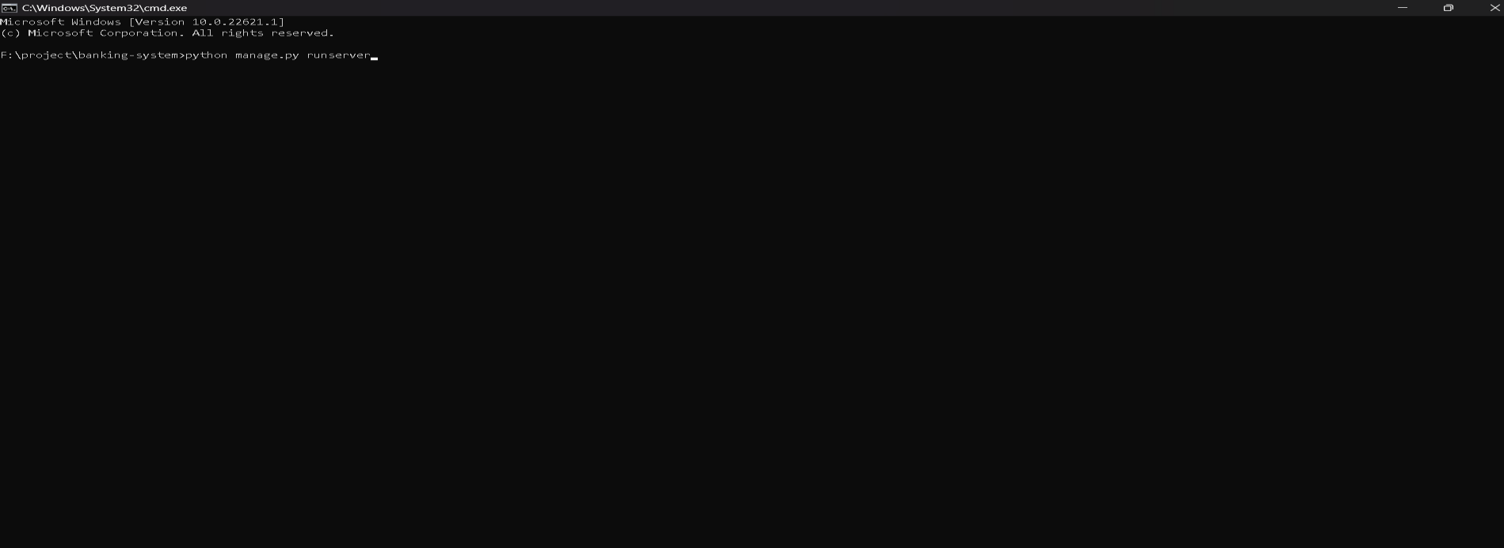**A.9.1 COMMAND PANEL**

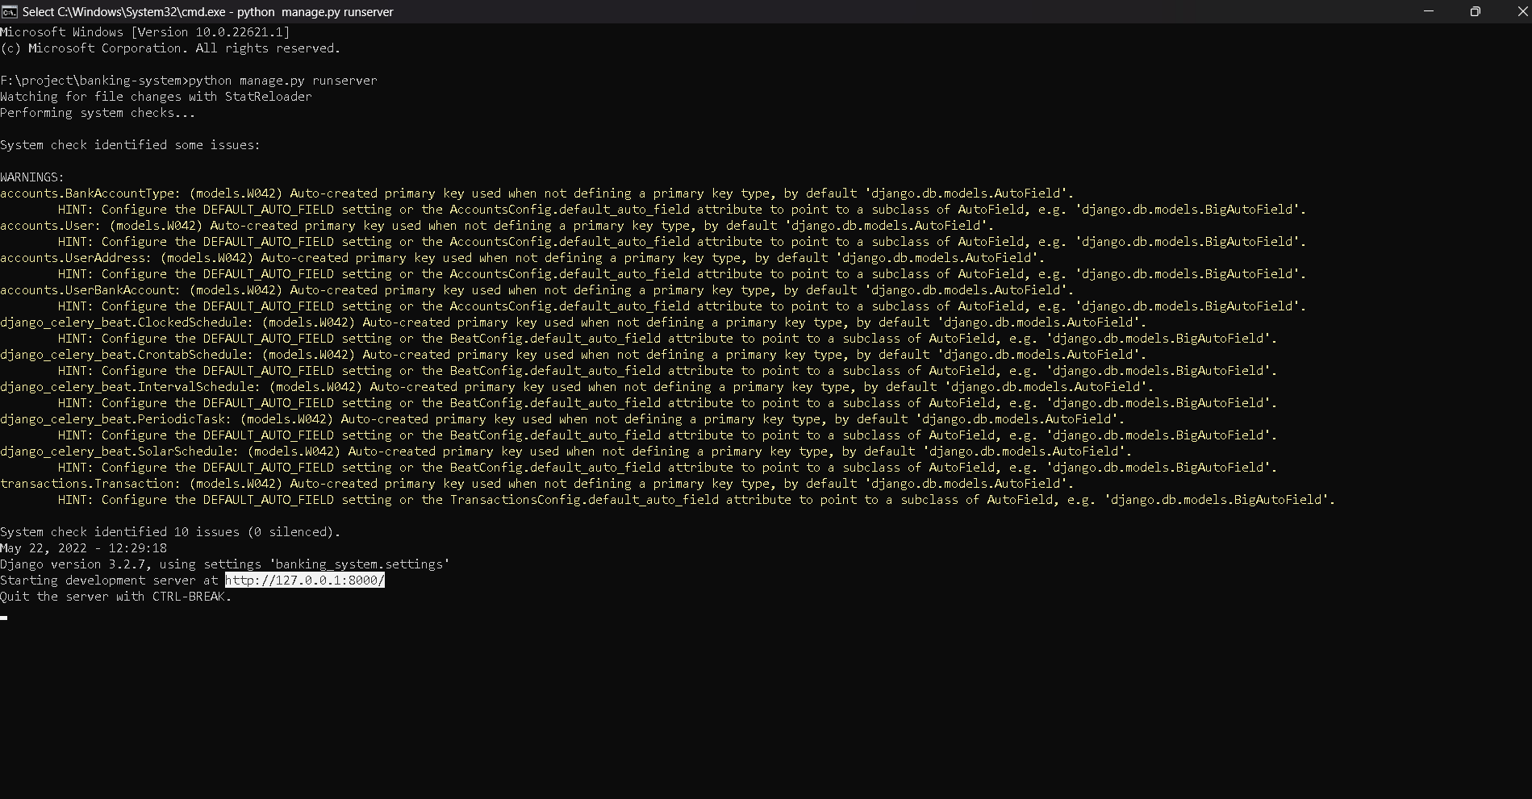**Fig.A.9.1-Command Panel A.9.2WEBSITE IS RUNNING :**

###### Fig.A.9.2-Website is running

**A.9.3.XAMPP TO CONNECT WEBSITE WITH DATABASE :**

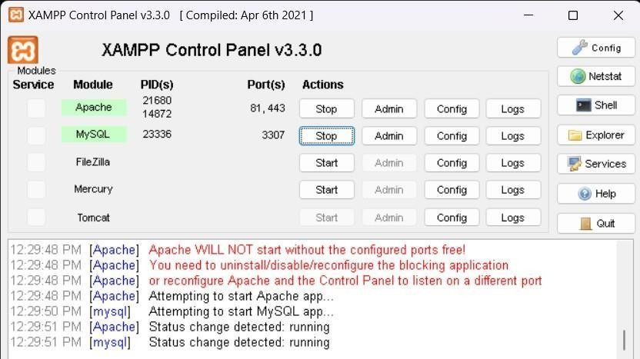

###### Fig.A.9.3-XAMPP To connect website with database

* + 1. HOME PAGE :

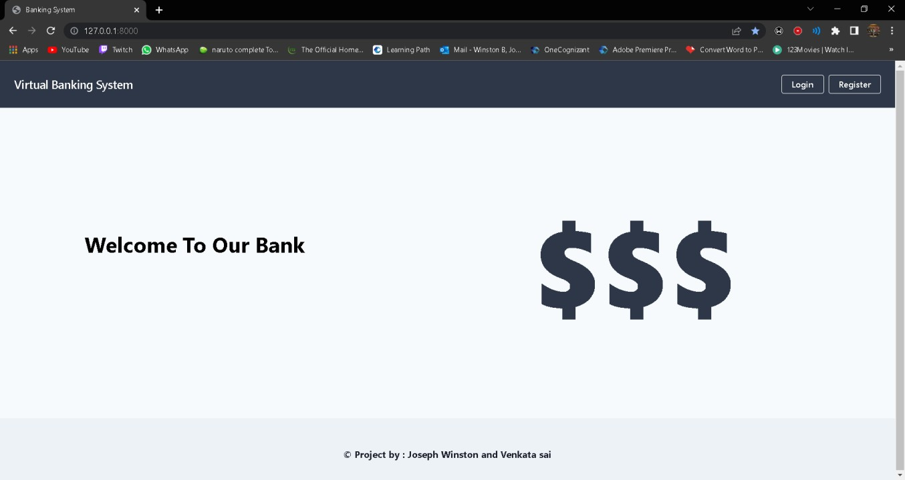

###### FigA.9.4-Home page

* + 1. REGISTER NEW USER :

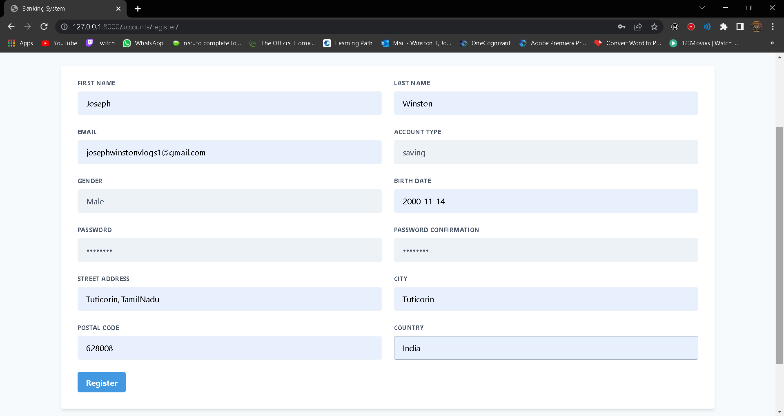

###### Fig.A.9.5-Register new user

* + 1. ERROR DETECTING SAFETY MEASURES :

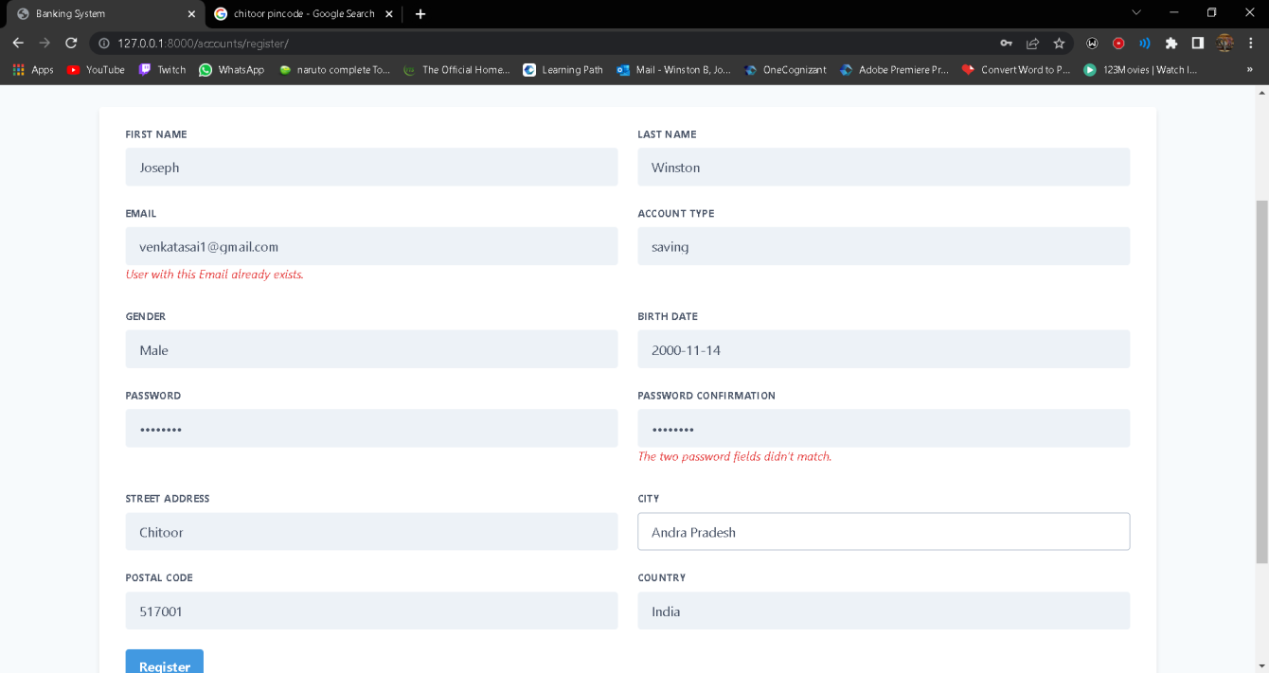

###### Fig.A.9.6-Error detecting safety measures

* + 1. DEPOSIT PAGE :

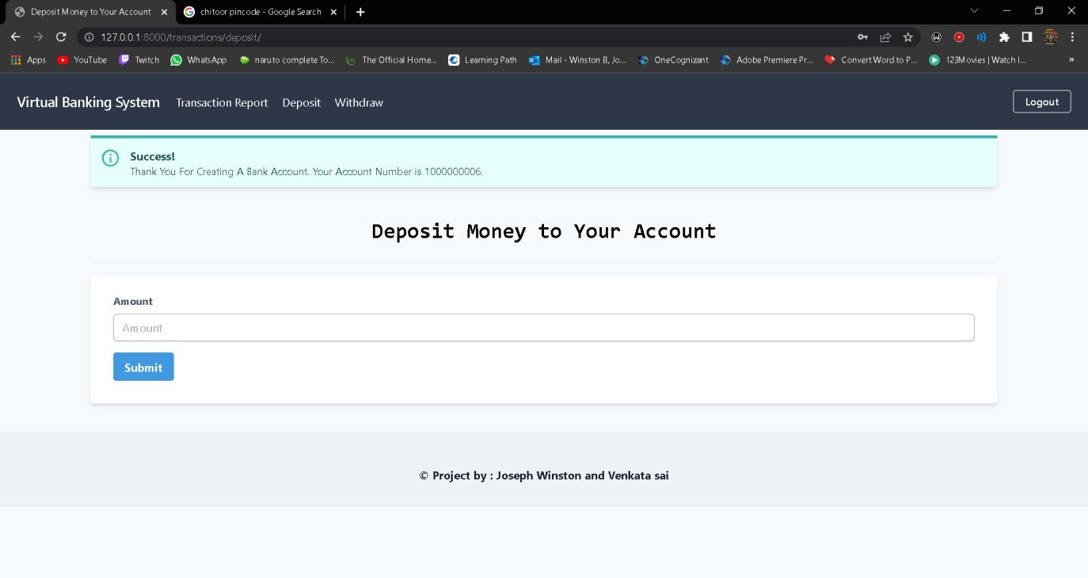

###### Fig.A.9.7-Deposit page

* + 1. TRANSACTION REPORT PAGE :

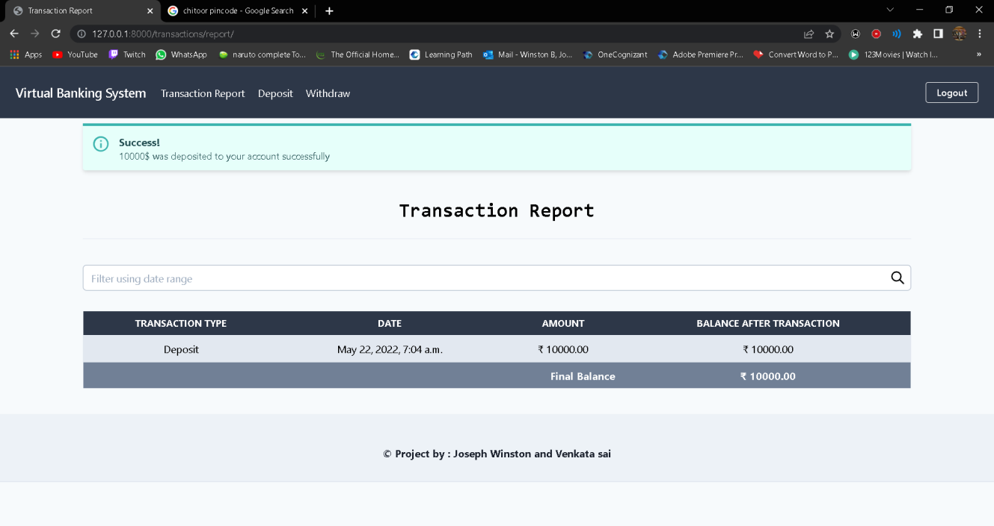

###### Fig.A.9.8-Transaction report page

* + 1. WITHDRAWAL PAGE:

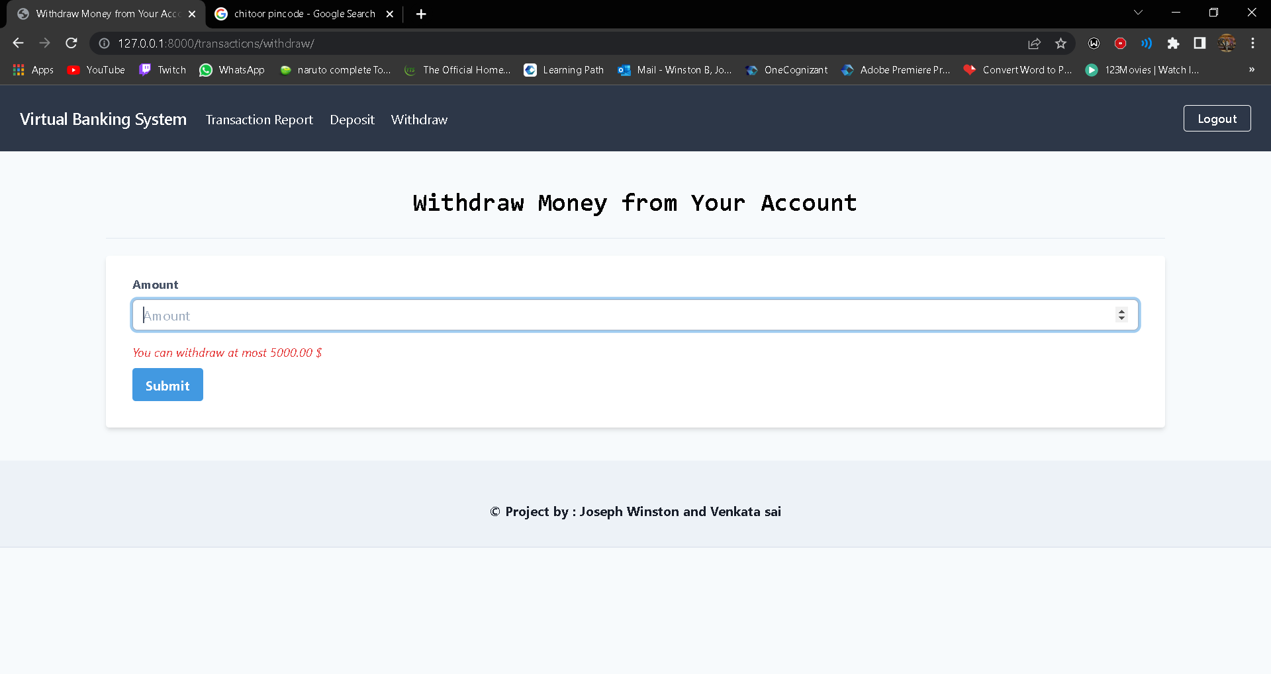

###### Fig.A.9.9-Withdrawal page

* + 1. UPDATED TRANSACTION REPORT:

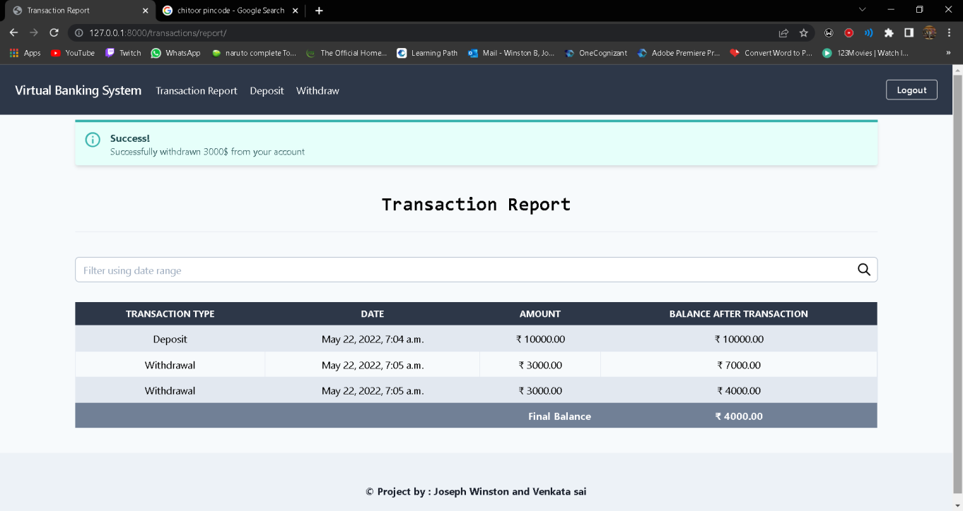

###### Fig.A.9.10-Updated transaction report

* + 1. ADMIN LOGIN:

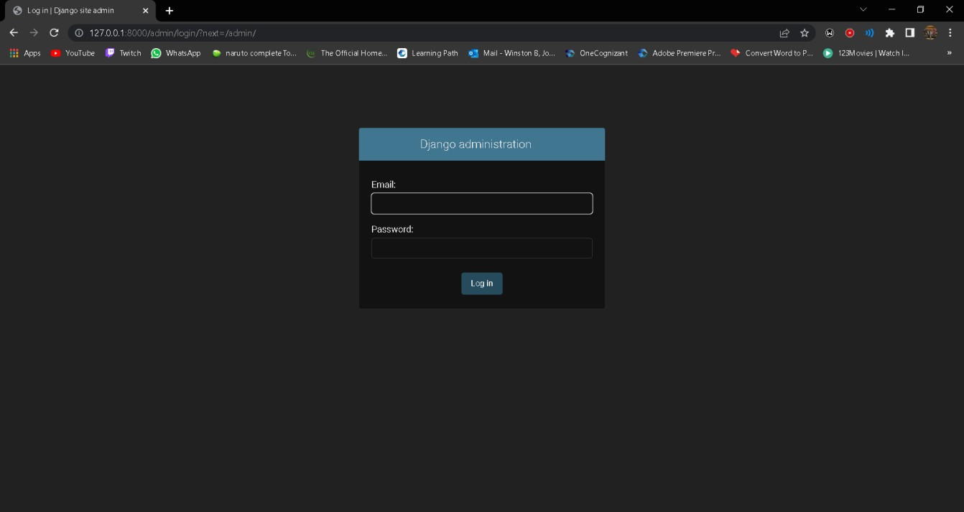

**Fig.A.9.11-Admin login**

* + 1. HOME PAGE FOR ADMIN:

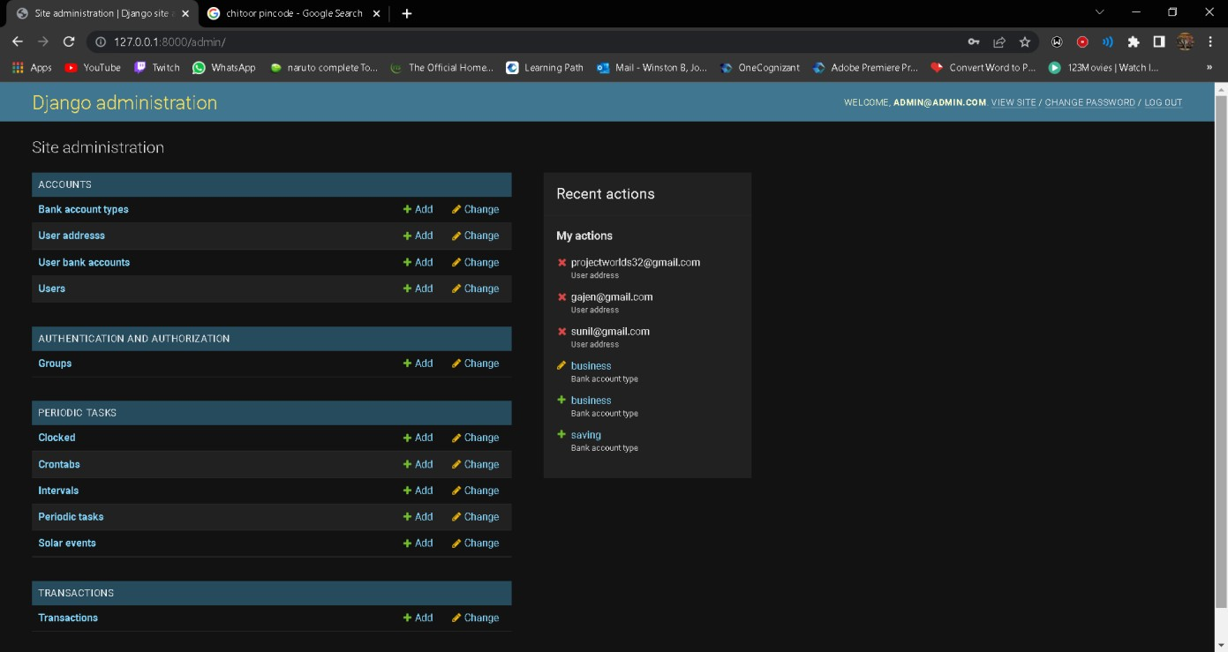

###### Fig.A.9.12-Home page for admin

* + 1. VIEW TOTAL LIST OF USERS:

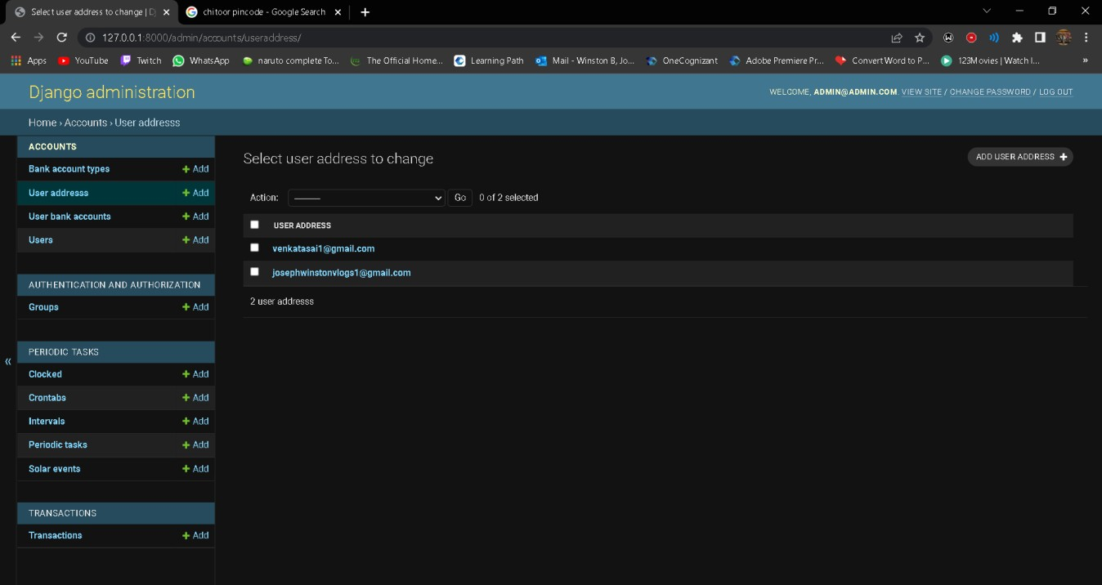

###### Fig.A.9.13-View total list of users

* + 1. VIEW TRANSACTION REPORT AND EDIT:

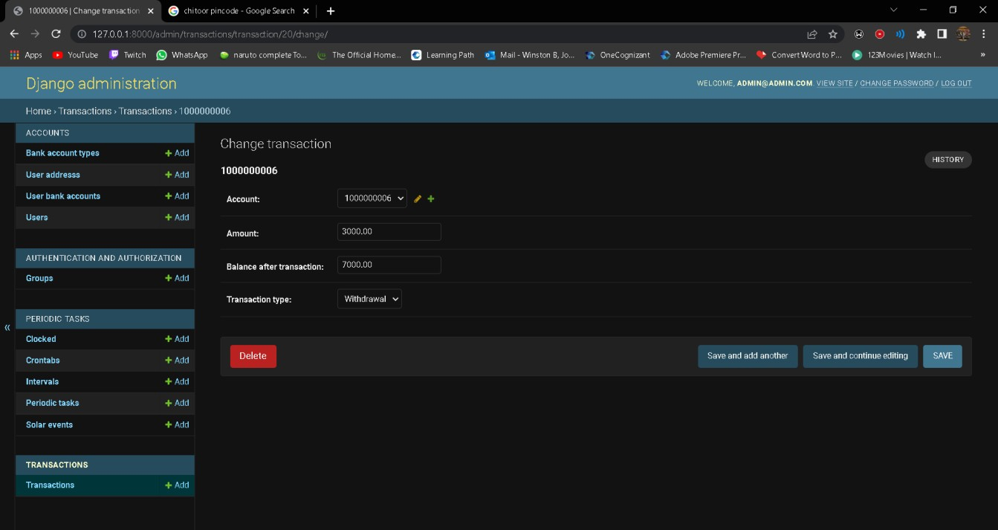

**Fig.A.9.14.-View transaction report and edit**

* 1. **REFERENCES**

1. Allayer fard, Mahmood, 2005, Iran central bank
2. Azimi Husseini, Anita, seasonal economic studies, iran20
3. Babazadeh, Mahmood, 2005, Azad Islamic university
4. Basle Committee on Banking Supervision, (1998), Risk Management for Electronic Banking and Electronic Money Activities, PP. 51-62.
5. Brian Mantel (2000), Why Do Not Consumers Use Electronic Banking Products?, Emerging Payment Occasional Paper Series. PP. 47-54.
6. Chanaka Jayawardhena, Paul Foley (2000), Changes in The Banking Sector the Case of Internet Banking in The UK, Internet Research: Electronic Networking Applications And Policy, Vol. 10, No. 1, PP. 19-31.
7. Chanaka Jayawardhena, Paul Foley (2000), Changes In The Banking Sector The Case Of Internet Banking in The UK, Internet Research: Electronic Networking Applications and Policy, Vol. 10, No. 1, PP. 19-31.
8. Daniela Rusu & Octavian Dospinescu (2004), The Adoption Electronic Banking Services in Developing Countries, Department of Business Information Systems. Bd Carol Inr, PP. 20- 35.
9. Heikki Karjaluoto, Mina Mattila, Tapio Pento (2002), Factors Underlying Attitude Formation Towards Online Banking in Finland, International Journal of Bank Marketing, Vol. 20, No. 6, PP. 261-272.

84

1. Ibrahimi, Shahed (2002), The Obstacles of Electronic Banking in Iran, Thesis for MA, Faculty of Management & Accounting, Allameh Tabatabaei University; Tehran. PP. 25-48.(In Persian)
2. Jamshidi, Abdolghasem, 2000, MA proposal Azad Islamic university
3. Kabir Hassan, Mohammad, 2003, 13th conference of currency and exchange policy, study room of banking,Tehran, iran centeral bank
4. Kolodinsky .Jane M, Jeanne M. Hogarth, Marianne A. Hilgert(2004), The Adoption of Electronic Banking Technologies by US Consumers, International Journal Of Bank Marketing, Vol. 22, No. 4, PP. 238-25
5. Lotfi, mohammad, 1998, Tehran business study institution
6. Nexhmi Rexha (2004), The Impact of The Relational Plan on Adoption of ElectronicBanking*,* Journal of Services Marketing, Pp 20-42.
7. Sylvie Laforet, Xiaoyan Li(2005), Consumers’ Attitudes Towards Online And MobileBanking In China, International Journal Of Bank Marketing , Vol. 23, No. 5, Pp. 362-380.
8. [www.sbank.ir](http://www.sbank.ir/)

85